MINUTES OF MEETING EAST HOMESTEAD
COMMUNITY DEVELOPMENT DISTRICT

A regular meeting of the Board of Supervisors of the East Homestead Community Development District was held Friday, January 27, 2020 at 9:00 a.m. at the Oasis Community Clubhouse, 171 NE 30 Road, Homestead, FL 33033

Present and constituting a quorum were:

Susan Genther Laurie Weil Stephen Walker Raymond Harris Saens Dorcely

Also present were:

Vanessa Steinerts Luis Hernandez George Graupera Ernie Abreu
Al Torres
Chairman
Vice Chairman Assistant Secretary Assistant Secretary Assistant Secretary

District Counsel District Manager District Engineer
Soliman Structures, Inc. Resident

Segment I:
FIRST ORDER OF BUSINESS

Roll Call and Pledge of Allegiance

Mr. Hernandez called the roll and stated we have a quorum, and the Pledge of Allegiance was recited by all who attended the meeting.

SECOND ORDER OF BUSINESS Audience Comments - As per
District's rules, each speaker has 3 minutes to provide comments
Mr. Hernandez: So, as part of the regular agenda, are there any audience comments, Al?
Mr. Torres: No, thank you.
Mr. Hernandez: With that being said, let's move on to the workshop.

Segment II: Workshop Section
THIRD ORDER OF BUSINESS

Discussion of Results of RFP

(At this point the Board went into the workshop section to discuss the following items)

- Presentation from District Engineer
- Presentation from Vendors
- Discussion and Direction

FOURTH ORDER OF BUSINESS

Segment Ill:
FIFTH ORDER OF BUSINESS
Updates on Status of Any Projects and Workshop Items

Authorization or Approvals Requiring Board Action for Items Discussed During Workshop

Mr. Hernandez: So, coming back to the record, and after the discussion what has
taken place, it is my understanding that the Board wants to proceed and move forward with Soliman Structures, Inc. If that is the case; it would be a motion appointing Soliman Structures, Inc. as the #1 qualified ranked company for the clubhouse improvement project.

On MOTION by Ms. Weil seconded by Mr. Walker with all in favor, accepting and appointing Soliman Structures, Inc. as the #1 ranked company for the clubhouse improvement project was approved.

Mr. Hernandez: As I was indicating through the workshop, it just means that the District is going to be putting all the documents together, setting them up, and I will be working on the schedule. As we get more specifics hopefully at the next meeting, I will be able to elaborate more to the Board as to what that timetable will be and so forth.
Mr. Harris: That was the one item because we're moving the dates for things that are happening in the month of March, I would assume that Ernie, if we got back to him and said, we would like to start on or around the March 20th date that he would be able to accommodate us, knowing what he said.

Ms. Genther: That does bring to mind though, do we want to go ahead and notify the clubhouse management that maybe they should not take anything for obvious reasons.
Mr. Hernandez: I already told them to stop booking reservations. Mr. Harris: Good.
Ms. Steinerts: Is the intention to approve the final contract at the next meeting? Mr. Hernandez: If we're ready to present it.
Ms. Steinerts: It can be ready to be presented, I will not be at the February or March meetings. 1,(
Mr. Harris: Do you know who will be?
Ms. Steinerts: Most likely it will be Mike Pawelczyk, but I will be back after that.
So, I can have the agreement ready to be presented.
Mr. Hernandez: Perfect. Mr. Harris: Thank you.
Ms. Steinerts: I don't know if the Board has looked at the agreement.
Mr. Hernandez: It was presented at the prior meeting to be included as part of the package.
Ms. Steinerts: Ok, so if you do have any questions, feel free to contact me. Mr. Hernandez: Alright.

SIXTH ORDER OF BUSINESS Adjournment
Mr. Hernandez: With that being said, unless anyone the Board has any other further discussions to undertake, a motion to adjourn the meeting would be in order.
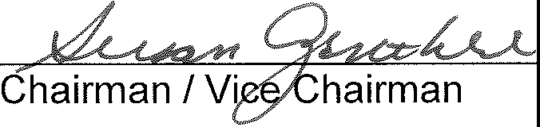

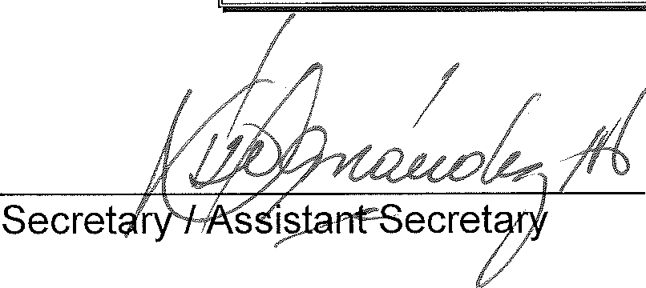
On MOTION by Ms. Genther seconded by Mr. Harris with all in favor the meeting was adjourned.

