East Homestead Community Development District
www.easthomesteadcdd.com

Susan Genther, Chairperson Laurie Weil, Vice Chairperson Saens Dorcely, Assistant Secretary
Raymond Harris, Assistant Secretary Stephen Walker, Assistant Secretary

ApriI 27, 2020


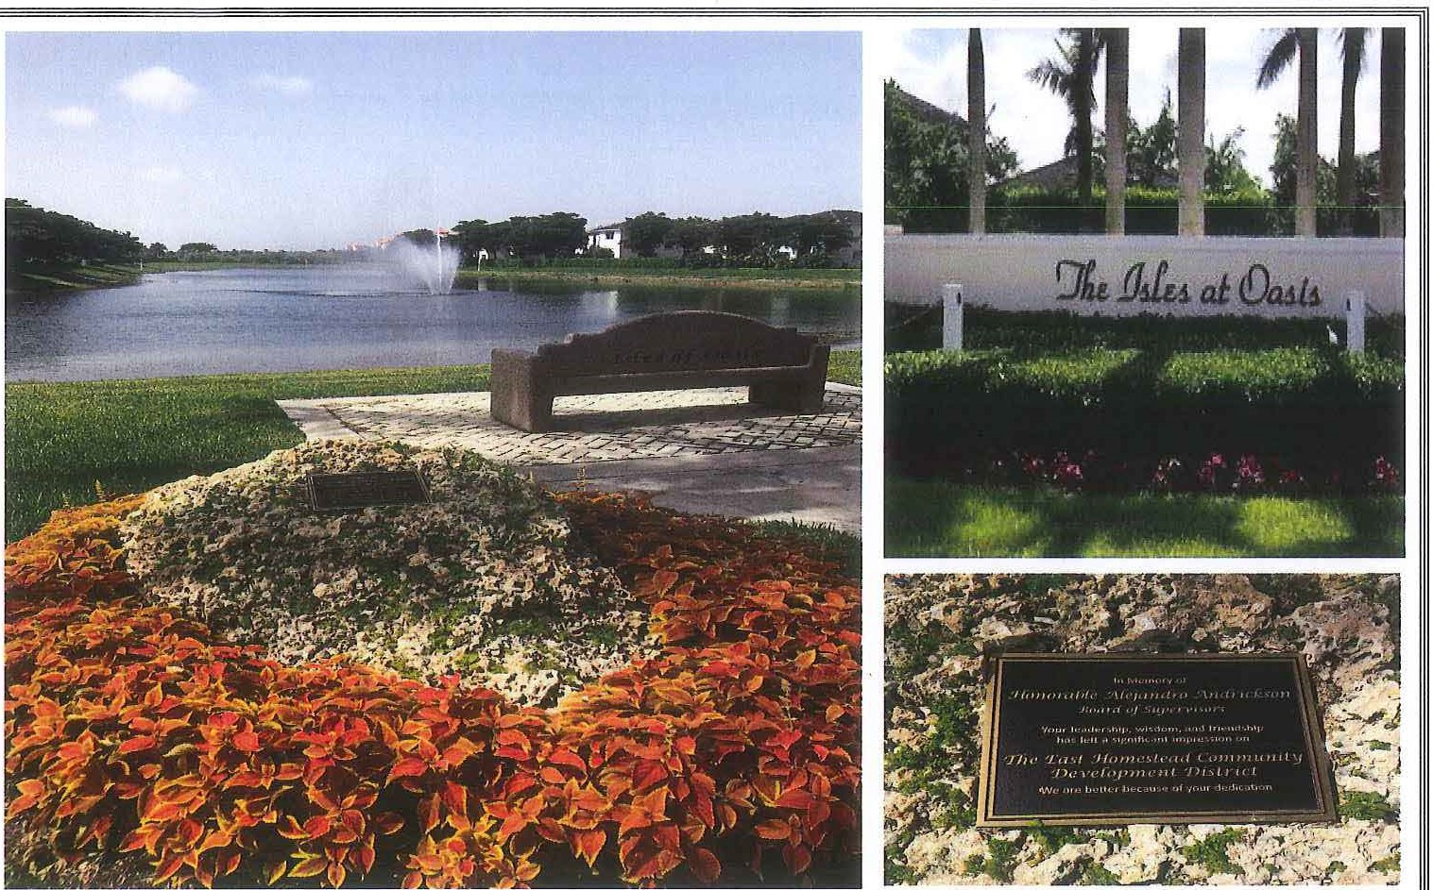
Governmental
h4anagemenl Services
...

East Homestead
Community Development District
5385 N. Nob Hill Road, Sunrise, Florida 33351
Phone : 954-721-8681 • Fax: 954-721-9202
April 17, 2020
Board of Supervisors East Homestead
Community Development District
Dear Board Members:
A telephone conference meeting of the Board of Supervisors of the East Homestead Community Development District will be held on April 27, 2020 at 9:00 a.m. In accordance with Office of the Governor, Executive Order 20-69 (Emergency Management - COVID-19 - Local Government Public Meetings), authorizing the use of communications media technology, such as telephonic conferencing, as provided in Section 120.54(5)(b)2, Florida Statutes, the Board of Supervisors and members of the public may attend and participate in the meeting utilizing the following call-in information: 1-866-730-7514, Participant #857817 and are further encouraged to submit comments or questions in advance of the meeting by email to info@gmssf.com or by telephone by calling 954-721-8681. Following is the advance agenda for the meeting:
Segment I:
- Roll Call
- Audience Comments - As per District's rules, each speaker has 3 minutes to provide comments.
Segment II - Workshop Section:
  - Discussion of the Minutes of the March 13, 2020 Meeting
  - Discussion of Results of RFP for Clubhouse Gym Remodel (results will be presented and distributed at meeting)
    - Presentation from District Engineer
    - Presentations from Vendors (if appropriate and beneficial)
    - Discussion and Direction
  - Updates on Status of Any Projects and Workshop Items
Segment Ill:
- Authorization or Approvals Requiring Board Action for Items Discussed During Workshop
  - Approval of the Minutes of the March 13, 2020 Meeting
  - Motion as a Result of RFP Discussion for Clubhouse Gym Remodel
  - Any Other Approvals
- Staff Reports
  - Attorney
  - Engineer
  - Club Manager - Monthly Report
- Club Maintenance during Closure
- Clubhouse Enhancements Proposal
- Estimate from Fast Signs
  - Field Manager - Monthly Report
  - COD Manager - Discussion and Consideration of Adsum Group Invoice
- Financial Reports
  - Approval of Check Run Summary
  - Balance Sheet and Income Statement
- Supervisors Requests
- Adjournment
Meetings are open to the public and may be continued to a time, date and place certain. For more information regarding this CDD please visit the website: http://www.easthomesteadcdd.com
MINUTES OF MEETING EAST HOMESTEAD

COMMUNITY DEVELOPMENT DISTRICT

A regular meeting of the Board of Supervisors of the East Homestead Community Development District was held Friday, March 13, 2020 at 9:00 a.m. at the Oasis Community Clubhouse, 171 NE 30 Road, Homestead, FL 33033

Present and constituting a quorum were:

Susan Genther Laurie Weil Stephen Walker Raymond Harris Saens Dorcely

Also present were:

Michael Pawelczyk Luis Hernandez
Alexandra (Alex) Garcia David Osio
Al Torres
Chairman
Vice Chairman Assistant Secretary Assistant Secretary
Assistant Secretary (by phone)

District Counsel District Manager
NFC Amenity Management NFC Amenity Management Resident

Segment I:
FIRST ORDER OF BUSINESS Roll Call and Pledge of Allegiance
Mr. Hernandez called the roll and stated we have a quorum, and the Pledge of Allegiance was recited by all who attended the meeting.

SECOND ORDER OF BUSINESS Audience Comments - As per
District's rules, each speaker has 3
minutes to provide comments
Mr. Hernandez: Moving on to audience comments, does anyone from the audience have any comments? Not hearing any, we can move on to the workshop where we can undertake the items.

Segment II: Workshop Section
(At this point the Board went into the workshop section to discuss the following items)

  - Consideration of the Minutes of the February 14, 2020 Meeting
  - Discussion and Consideration of Adsum Group Invoice
  - Discussion of Martinique Concerns
  - Discussion of Gym Improvements and Necessary Steps
  - Updates on Status of Any Other Projects and Workshop Items

Segment Ill:
THIRD ORDER OF BUSINESS Authorization or Approvals
Requiring Board Action for Items Discussed During Workshop
- Approval of the Minutes of the February 14, 2020 Meeting
- Any Other Approvals
Mr. Hernandez: Coming back on the public record, the first action the Board needs to consider will be the approval of the minutes of February 14, 2020 with no corrections, additions or deletions.
Ms. Genther: I think that's the first time in 10 years, so I make the motion.

On MOTION by Ms. Genther seconded by Ms. Weil with all in favor, the Minutes of the February 14, 2020 Meeting were approved.

Mr. Hernandez: Moving forward, is the Board ready to consider the estimate from Ortiz for the playground area in the amount of $8,632 with the understanding so that it's on the record, that it will only be taken if the surface is going to be kept even?

On MOTION by Mr. Harris seconded by Ms. Genther with all in favor, accepting the proposal from Ortiz Construction for the playground area in an amount not to exceed $8,632 as stated on the record was approved.

FOURTH ORDER OF BUSINESS Staff Reports
Mr. Hernandez: So now that takes us to the next item, staff reports, Mike?
- Attorney - Approval of Fee Structure Adjustment
Mr. Pawelczyk: Yes, we have one item on the agenda. The first thing that I will say is we have not increased our rates since 2003, and really if you know anything about legal rates, these rates are still relatively low, but this is really our business model, so what we propose is, you see the rates there, and I'm going to tell you what are current rates are. We have been charging for partners $220 per hour since 2003, associates gets $175 per hour, paralegals $55 an hour, and we don't have any paralegals so we kind of took that off here, and then a monthly minimum fee of $500, and what the minimum fee is, if we don't exceed, in other words, there's a lot of work that gets done that doesn't get billed, whether it's maintaining the files, etc. that monthly minimum is only charged if our hourly billing doesn't reach $500, so I don't think it's going to happen but we're going to leave it in there and our current monthly minimum is $500, but I don't think it's ever going to be implemented. In other words, that's not an additional charge, it's only if we don't exceed that.
Mr. Walker: In my opinion we've been getting excellent legal service for an excellent price, while this new price is still a very good price.
Mr. Pawelczyk: Yes, and we did the CPI increase, the increase reflects a 39.4% increase since the year 2003, but these rates are considerably under that, but we didn't want to jump up too much and what we've done under this letter is every 3 years we'll revisit this. We kind of started doing this when we first started increasing our rates around 7 years ago, we just haven't done it here, and one of the reasons we haven't done it, I think it's just because there's been so much work that this District had us do, that we were so busy we didn't want to impact the budget. We don't think this is going to impact the budget, particularly since Vanessa is doing a lot of your work, and actually a majority of it, and she's an associate but who knows, maybe she'll be a partner next year, but I can't say that for sure because I don't have any decision making authority on that. So right now, I think this would be the increase we'd be asking for and if there are any questions, I'd be happy to answer them, otherwise a motion to authorize the new rates as set forth in that engagement letter would be in order.

Ms. Genther: I would just like to say, Mike you were not here, we had a proposal to increase GMS rates also recently, and my statement to them at the time was, it's about time, I've been asking to increase fees every time we do our budget for years, and that's

the same thing with your firm. I am all for this, so I make the motion to increase Billing, Cochran rates.

On MOTION by Ms. Genther seconded by Mr. Harris with all in favor, accepting the engagement letter with Billing, Cochran, Lyles, Mauro & Ramsey, P.A. for the fee structure adjustment as stated on the record was approved.
Mr. Harris: Thank you for all your years of service.
Mr. Pawelczyk: Well, thank you and to the District itself for sticking by us and GMS, we've all kind of been partners in this a long time, and I'm just kind of glad to be back, I told Luis to cover for Vanessa in terms of her having to be out today, but there was another opportunity for another lawyer to come down here who was headed to the Keys, and I said no, I want to go and cover the meeting. We kind of set it up where most of our Districts, we try to make sure there's someone on back up, just like if you don't have to go to the meeting if you have a vacation planned or whatever, so you want to bring someone in that kind of at least has an idea as to what's going on in the District, and in this case you have 3 lawyers that can do that. So, we'll continue with that, and thank you very much for your motion. I do have one other item I want to bring up, and it has to do with an executive order that Governor Desantis signed on the 9th, and it's Executive Order 20- 52, it's not in your package, I actually have in my email, I'll send it to Luis if they don't already have it, but one of the things that this executive order does is, there is actually a Florida Statute, Section 252.38 that deals with emergencies and how it affects political subdivisions, like municipalities and Special Districts. So, one of the things this executive order does is it authorizes each political subdivision within the state to waive the procedures and formalities, otherwise required by political subdivisions with respect to the performance of the public work and taking whatever prudent action is necessary to ensure the health, safety and welfare of the community, entering into contracts, and that's really certain contracts, it doesn't mean we can't enter into the clubhouse remodeling contract. Although, in this case it would be nice if we could, but that's not the intent of this. Incurring obligations, the employment of permanent and temporary workers, utilization of volunteer workers, the rental of equipment, acquisition and distribution with or without compensation, of supplies, materials and facilities, and the appropriation

expenditure of public funds. So, one of the things that I think would be appropriate would be for the Board to, in other words, if Luis were to take any of these actions that are in the executive order, what he would do is bring it back for ratification. I think any extra expenditures, if we have to rent equipment or whatever, he's going to bring it back to ratify for the Board, but I think it would be appropriate in this circumstance to move to authorize the manager to act within the confines of the executive order, even if he's running it by one of you, whether it's the chairman, vice chairman, or however you want to handle it, but I just think it would be appropriate to recognize that, and the emergency of course relates to the pandemic for the Coronavirus.

On MOTION by Mr. Walker seconded by Ms. Weil with all in favor, authoring the District manager to act within the confines of the Executive Order relating to the pandemic for the Coronavirus was approved.

Mr. Pawelczyk: That's all I have for our report, unless you have any questions.

- Engineer
Mr. Hernandez: Hearing no questions, as to the engineer, the reason that George isn't here today, and he and I are in contact all the time, the only pending item from the engineer as of now, is the pending construction for the drainage system that goes with all the inside parts of the two sides of the community, that is still being held by the City of Homestead, the lady who is handling that still has that on hold. The only good news and I don't know what is going to be the outcome, I did receive a text from a representative coming from Carlos Gonzales from Lennar and it appears that they want to talk to me as to what is going to be the improvements. It is my understanding, and as I have said in the past, one of the actions that I have been taking is, based on the people that I know, see how proactively the District can easily be reached so if anything needs to be done, let's get it done and let's move on. It appears as of this point that some kind of conversation will take place, and I will keep the Board posted as I get to know more details. It saddens me that we're being kept hostage on something that we have nothing to do with, but once again, the lady continues to prove it despite the efforts from the commissioner and so on, that she's successfully holding us up.

Mr. Walker: The only person that can override her is the city manager.
Mr. Hernandez: The part I'm going to be checking is in the order of the Governor, and I do believe that was sent already.
Ms. Genther: Is there any value in contacting, I believe his name is Jose from Capri, who has been kind of proactive in coming to the meetings about the drainage issue over there, and to let him know that it's still in process, that we're still having that issue, to at least let him know?
Mr. Harris: Well, wouldn't you want to go to Hercules because he's the president of the HOA?
Ms. Genther: Yes, Hercules, but also Jose, because Jose is the one who's been coming here for the last year about the drainage, but you're right Ray.
Mr. Hernandez: Let me tell you there's another approach, and please guide me if you believe this is wrong. We're doing it at the time on the public record, so if anyone wants to see it, they will be able to read it in the minutes. My only concern is that if you go and you tell me that's it, and then you say to someone else, then how many more people do I need to be contacting for something that I don't know if they have an interest. Keep in mind, everything that I'm sending, and the responses that I'm receiving becomes public record, so what I normally do is if they call me or they ask me, I respond, and if not, go to the minutes and you can see them there.
Ms. Genther: It's just that he has expressed interest in this, that's all.
Mr. Hernandez: He knew the hiccups that we were having, and he was aware of the city requesting what needs to be fixed, or whatever they're trying to do at the roundabout, what I believe needs to be done at the end of those roads, that's as much as I know.
Ms. Genther: Ok, I was just trying to be nice.

- Club Manager - Monthly Report
  - February's Pool Area
  - February's Gym Area
  - Supervisor of Elections Setting
  - Landscaping Concerns
  - Fast Signs Estimates
  - Roberts Aluminum Quote
Mr. Hernandez: Moving on to club manager report, Alex?

Ms. Garcia: Ok so, you guys have the pool head count in here and we do have the gym head count as well. The next one is the setting up for the elections that's coming up.
Ms. Genther: But that's no longer the issue, right?
Mr. Hernandez: We're going to continue doing it that way, and just for the Board to know, it is in the best interest of us to know that prior to moving that over here, and keep in mind right now in March is not going to be as many people as it would be in November, so we want to know exactly how it's going to be work.
Ms. Genther: And November is the presidential election.
Mr. Hernandez: Hopefully by November we will be done and ready, but part of what we want to test is how it works. It appears that it's going to be perfectly fine, the only item that needs to be recognized, and there will be a sign, is that this is the only way to get to the bathrooms. So, people will still have to come through this area, but we're going to try to get people to go through here so they are not socializing in here and affect the election process.
Ms. Genther: And I will say, the 2018 election that the line went out the door, and that was not even a presidential election, and I think the presidential election is going to be well attended.
Mr. Hernandez: I think it's a good way for us to test what the District is doing will work, and if not, we will have time to come and change it.
Ms. Garcia: The next item I have is it shows images of the front area of what BrightView has done to the grass with their machines, going on to the grass to cut the grass and whatnot. It has been improved, sod was ordered, and they improved that area, including the areas around the whole club if you've noticed.
Mr. Walker: I did, and it really looks nice.
Mr. Harris: I wasn't here at the last meeting because of a personal family issue I was dealing with but I wanted to commend you and your staff on what you did on the island between the parking lot and the entranceway here in putting in the border and putting in the river rock and stuff, that was a lot of work and it really looks nice.
Ms. Garcia: On that note, we can move on to the next item which a proposal from Fast Signs, and this proposal is to add additional signs and replace signs that we have

within the clubhouse and outside the clubhouse and as you can see a lot of our signs look outdated. That proposal comes out to $2,199.23.
Mr. Hernandez: The request from staff at this point is to authorize the expenditure of $2,200 for signs.

On MOTION by Mr. Walker seconded by Mr. Harris with all in favor, accepting the proposal from Fast Signs in an amount not to exceed $2,200 for signs in and around the clubhouse was approved.

Ms. Weil: Ok, just one question, these are signs, I just noticed on one of them that said that they have the bonded tape strips on the back so they can be removed I guess, because when we go to paint and renovate and all that.

Ms. Garcia: They will not be able to, they will not be removed, they can be painted around, and we can cover them, but these signs, they're also attached.
Ms. Weil: So, we might have to do these all over again in 6 months?
Mr. Hernandez: No, not all of them. The part that I don't know is the specifics, but once you approve something, then I get involved with the details, where each one of the signs will be going, a big portion of it will be in areas that will not be in the construction, and if anything is going to be done in the construction area, I will make a determination of whether it would make sense to do it now, or if it needs to wait until after the construction is done.
Ms. Weil: Right, because we are going to be painting and everything too.
Ms. Genther: And I think Laurie's point is a good one, if we're going to be doing a refurbishing of the entire facility, do we want to do this, but on the other hand, if we don't go ahead and do it, it would be another year before we actually apply paint to a wall.
Mr. Hernandez: Not only that, any type of sign I take it that it's an indication that it needs to be given to whoever is trying to use it, so it needs to be kept well and properly maintained. If that means that we're going to be restoring an area, I will be taking that as part of the cost of restoring that. Once again, now that it has been approved, I will get involved in the details, but if anything can be delayed because of potential plans, it will be done.
Ms. Weil: Ok.

Ms. Garcia: And the last item that I have is to order 3 more umbrellas, if you notice the splash pad, we have 3 of the older style umbrellas and they're about to go, so I figured it would be best for us to replace them with the newer style that we have.
Mr. Hernandez: Prior to the summer.
Ms. Weil: Right, before the summer season.
Mr. Hernandez: And for that reason, the cost that is being presented to the Board is $1,125, and the part that I have checked is that the price is reasonable, and we have used them before.
Ms. Weil: Right, is it the same price that we've been paying? Ms. Garcia: Yes.

On MOTION by Mr. Walker seconded by Ms. Weil with all in favor, accepting the proposal from Roberts Aluminum Furniture to purchase 3 new umbrellas in an amount not to exceed $1,125 as stated on the record was approved.

Mr. Hernandez: Anything else? Ms. Garcia: No.
Mr. Hernandez: Any questions for Alex?
Ms. Garcia: Oh wait, I do have some more. I did want to mention that I am in the process of scheduling for CPR, the price would be for 8 employees to be trained for 2 years and 3 types of training would come out to $970, and I believe he was saying that will be the cost for the employees here.
Mr. Hernandez: Does it mean they want the District to pay for that?
Mr. Osio: No, the employees themselves will pay for everything because that's something they get to keep with them, and most CPR certifications they get to keep for 2 years.
Mr. Hernandez: Alright, so that's within my powers, so let me go ahead and resolve it, it's the first time I'm hearing that, and I want to discuss that with you.
Ms. Genther: I would like that to be discussed also.
Mr. Hernandez: So, let me first get a good feeling on that issue, and if needed I will bring it back to the Board.
Ms. Weil: And like I've said a thousand times, not just CPR but everything.
Mr. Osio: Yes, it will be CPR, first aid, and.AED.

Ms. Genther: But we don't need that, we don't have the machine.
Ms. Weil: Fire extinguisher training, throwing the lifesaving rings, ropes or whatever.
Ms. Genther: The AEDs, the defibrillator, and we don't have one of those so we wouldn't need that, but yes, I know we've talked about that before, we don't have to enter into that discussion right now.
Mr. Hernandez: Rather than expand it, and considering the meeting has been going on for quite a bit of time, let me get with NFC and get the fine details and once we have the specifics it will be passed on to the Supervisors. If any of the items are being presented require to come back to the Board, we will be discussing that at the next meeting. Anything else?
Ms. Garcia: No that's it, unless the Board has any questions. Mr. Hernandez: Hearing none, we can move on to the next item.

- Field Manager - Monthly Report
Mr. Hernandez: The next item you have is the field manager report, which you can see behind tab D. I hope that by keeping the Board posted with the drives and so on, and part of what I'm trying to do is an interaction of what is perceived from the field personnel. Are there any questions in regard to the report?
Ms. Genther: Yes, well it's not in the report, but why don't we have banners?
Mr. Hernandez: They are being installed this week, you asked me that previously, I meant to tell you, what we have is straight banners, so they were supposed to be putting them in the first week of March, but they just put up the ones in Baywinds, and if they haven't finished putting them in here, I know they are working in the area so Christmas Designers is in the area.
Ms. Genther: Ok, but we had said that rather than have them come out and take banners down and then come back another time and put banners up, to just go ahead and change them out each time so that we would not have an additional fee for installing the banners, and I believe that for 2 years we went ahead and put the spring ones up, when the holiday ones came down.
Mr. Hernandez: I had that conversation with Joe, the representative from Christmas Designers just on that matter, and what he said is that, number one, he and his firm doesn't feel comfortable in January to put up spring banners. Number two, there is no cost associated for the District.
Ms. Genther: Ok.
Mr. Hernandez: So, we do receive the discount, but we have been paying for that and they as a company are doing it because we believe that leaves them up to get people to enjoy the banner when spring comes.
Ms. Genther: Ok.
Mr. Hernandez: Alright, are there any other questions in regard to anything regarding the field manager?
Ms. Genther: I would like to say on the record, I'm not happy with not doing the drives, and I have expressed that for me, doing the drives with just Chris was basically sightseeing, and I can do that on my own, it was important to me to have somebody from one of the landscape companies whether it's BrightView or Tropical Touch.
Mr. Hernandez: Every other week, they are having the drive. Ms. Genther: Ok.
Mr. Hernandez: And they have been trying to contact you to let you know that is taking place, so as soon as we're finished, I can tell you what the schedule is.
Ms. Genther: Yes, I would like to know the schedule.
Mr. Hernandez: Because every other week he's meeting with BrightView, and he's meeting also with Roslyn and they are the ones doing the drive. He continues to be the weekly drives, but the personnel from the other vendors is being done every other week.
Ms. Genther: Ok, thank you.
Mr. Harris: Just for the record, I do my own drives periodically, I try to do it like the week before a COD meeting, and I just go around and I take my dog with me when I do it, but the things that I see I send an email to Luis and to Chris so that they can address what I've seen.
Ms. Genther: Ok, well we'll get it squared away.
Mr. Harris: And I was almost going to ask you before the meeting, what's happened to the banners Susie, because you're the banner person, so moving along.
Ms. Genther: Ok, thank you.
Mr. Hernandez: The only items I do want to emphasize and make everyone aware of, there were two dead palms on 152nd, and it was kind of a battle with the landscape person because they didn't want to touch it, and make a big deal out of it, but they were suggesting and the recommendation was to approach and special contract to remove them because they were underneath a powerline. What ended up happening just so the Board knows is GMS contacted FPL directly, and it took us awhile to find the right person to contact, but FPL came and removed the trees at no cost. It is part of their obligation to trim those trees, as a matter of fact as a result of that visit, later on another truck was being sent to trim all of those trees on 152nd with dead palms.
Ms. Genther: There was one other thing I just wanted to point out and it goes back to the minutes last month, I had made a comment about, oh how nice the lake maintenance company had noted that there were catfish in some of the lakes, we apparently don't have catfish any longer, apparently nobody saw any catfish when they were here the last time, so I'm just making that point.
Mr. Hernandez: Keep in mind that their report is indicating what they see at the time they're there, and if they come really early in the morning, the likelihood for them to see the fish is higher than if they come closer to noon.
Ms. Genther: And we may still have catfish but I just wanted to make that note.
Mr. Harris: Two other comments, we had a dead possum on the side of the road for like 2 days, and I spoke to Alex and she called BrightView and BrightView said that wasn't for them to pick up, and it went back and forth, and I kind of think that maybe Chris picked it up?
Mr. Hernandez: Yes. There are certain items that I'd rather go ahead and jump on to the solution rather than going around and around, and I have already kind of told that to Alex, whenever something is happening let me know, there is a gentleman who lives in the community and he will pick those up for free, all you need to do is contact him, and before we contacted him, he's out of town, that's when Chris stepped in and he just took care of it.
Mr. Harris: So, we contact you?
Mr. Hernandez: Yes, contact me directly, shoot me an email, or contact Chris. Mr. Harris: Ok.
Ms. Genther: There was a letter from Nelson and I don't see it, but a letter from Nelson about the Capri lake, and I don't know where it is, I can't find it.
Mr. Hernandez: It was under the field manager report. Mr. Harris: It was in the field report I believe.
Mr. Hernandez: Yes.
Ms. Genther: Well, that's what I thought too but I don't see it here, and I just wanted to make a comment on it.
Mr. Hernandez: I remember reading it. Ms. Genther: I did too, I read it online.
Mr. Hernandez: I believe you will find it on page 2 of the report, or if you go to page 60 on the IPad you will find it at the bottom.
Ms. Genther: Ok, it's not the letter itself, ok, and that's what I had read yes, thank you Luis. I just want to say that this is a standard complaint from him and I don't know that it's anything different than what we've been doing. Are we neglecting it, I kind of suspected that we are not?
Mr. Hernandez: Not only that, I think that it kind of highlights the items that we discussed at the time we were talking about Martinique and the issue with Martinique and I think that if anyone were to go and see it at that time, there would be indications as to why it is part of the regular contract that we have and there is an explanation why we see at this particular time, and it is also understood what steps the District is proactively taking to take into consideration everything that we have been working on. Anything else you want to ask?
Ms. Genther: I think that's it for this part.
Mr. Hernandez: Are there any other questions in regard to the field manager's report. Hearing none, then we can just move on to the next item.

- CDD Manager
Mr. Hernandez: As the COD manager, I have nothing to report, and once again, the next meeting based on what we have so far, will be the one on April 3rd. With that being said, are there any questions that you have for me? Hearing none, we can move on to the next item.
FIFTH ORDER OF BUSINESS Financial Reports
- Approval of Check Run Summary
- Balance Sheet and Income Statement
Mr. Hernandez: The next item is financial reports and you will find that in section 5, tab A contains the check run summary and tab B has the balance sheet and income statement. Are there any questions you have in regard to the financials?
Ms. Genther: Yes.
Mr. Walker: And I have one after Susie. Mr. Hernandez: Yes ma'am?
Ms. Genther: I'm trying to find exactly where it is, we have down there somewhere it talks about construction funds, and I just want to double check that we have the funds to do the construction for the gym.
Mr. Hernandez: Yes, we do, if you go to section 5B. Mr. Walker: On the first page, 5B?
Mr. Hernandez: Yes, and that will show you, the third column, the one that says capital projects, all that comes from bond proceeds, the District has $385,000 for those particular items. Out of all that, the only funds you have for the District to be able to take any actions, the only item is $5,679 because that is the bonds that were issued for the annexed parcel.
Ms. Genther: Ok, what I'm looking at, I'm pretty sure it's showing me that it's page 2, but it's on the 2013 bond, funds available for construction $367,000.
Mr. Hernandez: Yes, that's correct.
Mr. Walker: And that's on the summary page? Mr. Hernandez: Yes, it's the same one.
Ms. Genther: But aren't we looking at more than that for the construction?
Mr. Hernandez: Sure, keep in mind that we have, and let me just kind of describe to you what it is the District has. The general fund and it's the part where I need the Board to understand that I need to keep funds in different accounts based on what is intended to be done. Construction funds can only be used for public improvements, it's bond proceeds, and right now what I have done is, I'm not touching those funds unless it's going to be related specifically for the gym expansion project.
Mr. Walker: However, just a question, the general fund may be used for construction as well.
Mr. Hernandez: You are absolutely right, currently the District has roughly $2.4 million dollars.
Mr. Harris: Unassigned. Mr. Hernandez: Yes.
Mr. Walker: We have $2.4 and we have $385,000.
Mr. Hernandez: Correct, now that would be a correct statement because within the
$2.4 you have what is the current year's operation and maintenance. Roughly speaking, the District's budget is $1.4 million, roughly speaking what we're missing is 6 months, so what we need to spend from now on is $700,000. The purpose of the general fund is that it can be used for whatever the Board needs to authorize, but part of the numbers that I will check so you know when we are talking to Danny, is how much that cost would be. Right now, what I have in my head so the Board knows is, roughly in my head for that I think it would be $250,000, so in my head the District is right now contemplating potentially $1 million in improvements to get done.
Ms. Genther: And when you say $750,000 for the gym project, that includes new equipment or does that include the refurbishing of the entire building?
Mr. Hernandez: Just that side, the entire facility, it depends on what the different numbers are.
Ms. Genther: And which couches we decide to buy.
Mr. Hernandez: Not only that, if you're going to decide to replace those, if the Board is going to decide to physically replace and use tile again, it means that we need to remove what we have which will be time consuming. There are other options, for instance if you want to use another type of flooring, and there is new type of flooring that I will be suggesting for this facility, it's call vinyl, the one that you see, and it appears to look like tile, and when it is put on top of tile, the beauty that is has is that none of the marks will affect it, so you don't need to do any major repairs on the existing flooring, and it can be put on top of it, so the installation is faster, and it's cheaper, and the project can be accomplished in a short time period. So, it had a really fine look, the part is that my priority right now is to define what needs to be done in that area, and finalize this area, and as we move forward, we will be touching base with that.
Ms. Genther: Ok.
Mr. Walker: Ok, and you said that was for the gym, and the gym is $750,000?
Mr. Hernandez: This is what we have on hand in here. Mr. Walker: Right.
Mr. Hernandez: Once again, I am just keeping it as rough numbers, but as we get to be moving forward, I will put it in a table so that you can see everything. There are two things to be kept in mind, every year within the existing budget I always try to leave amounts that if it doesn't get to be used, it will be carrying forward to the next year. Meaning, that it's going to become a part of the pool of funds available for whatever you see. Part of the items that I normally try to do is that, I don't like those funds to lower too much, I'd rather go ahead and have a slight increase so that the amount of funds that are being taken out, get to be replenished with new funds of the income that we're collecting from the assessments that are being met. The second part that needs to be done is, I always keep an eye on the existing bonds, we already refinanced it, the original bonds that the community had, and the second bond that we did was in 2013 but right now, believe it or not, yesterday I was talking to a community telling them the interest rate is 1.8%. Now, the part that you need to check is that there are always provisions that let you know how soon you can refinance or not, but I'm always keeping in contact, so the second item that I always include in any of my Districts is that any kind of financial tool that can be used to lower the obligation in the debt is going to be a benefit for the District because we can continue having the same assessment for the homeowners that will represent an increase for them, but it's going to be additional funds coming to the District. You do need to keep in mind the addition that was being done with Portavita, that represents additional funds that are coming to the District and certainly there are some increases in the services that are being provided, so those are kind of the steps that I have been taken in the past to make sure that the existing amount of money that is available, will not be going too long, too soon.
Mr. Walker: Ok, thank you.
Mr. Hernandez: Are there any other questions? Then a motion to accept financials will be in order.

On MOTION by Mr. Harris seconded by Ms. Weil with all in favor, the Check Run Summary and the Balance Sheet and Income Statement were approved.

SIXTH ORDER OF BUSINESS Supervisors Requests
Mr. Hernandez: Are there any Supervisors requests at this time?

SEVENTH ORDER OF BUSINESS Adjournment
Mr. Hernandez: Hearing none, a motion to adjourn the meeting would be in order.


by Ms. Weil seconded by Ms. Genther with all or the meeting was adjourned.

Secretary / Assistant Secretary Chairman / Vice Chairman



Oasis Club Maintenance During Closu re East Homestead CDD

- Pressur e wash railing s in pool area Done 3/23/2020
- Paint railings in pool area
- Pressure wash furnit ure pool Done 3/20/2020
- Pressure wash pool deck Done 3/23/2020
- Pressure wash sidewalk in back of club
- Install edging in pool area to keep mulch in place
- Paint curbs in parking lot
- Pressure wash shed Done 3/25/2020
- Pressure wash Pool room and A/ C room entranc e
- Pressure wash garbage bins Done 3/25/2020
- Deep clean pool bathroom Done 3/18/2020
- Deep clean gym Done 3/18/2020- 3/20/2020
- Deep clean gym bathroom Done 3/25/2020
- Deep clean both Saunas Done 3/18/2020
- Sanding down Saunas Done 3/19/2020
- Clean ceiling fans
- Clean and repaint baseboards Done 3/24/2020
- Pressure wash outside windows Done 3/23/2020
- Dust A/C vents throughout facility
- Deep clean kitchen Done 3/18/2020

Please see below for images.
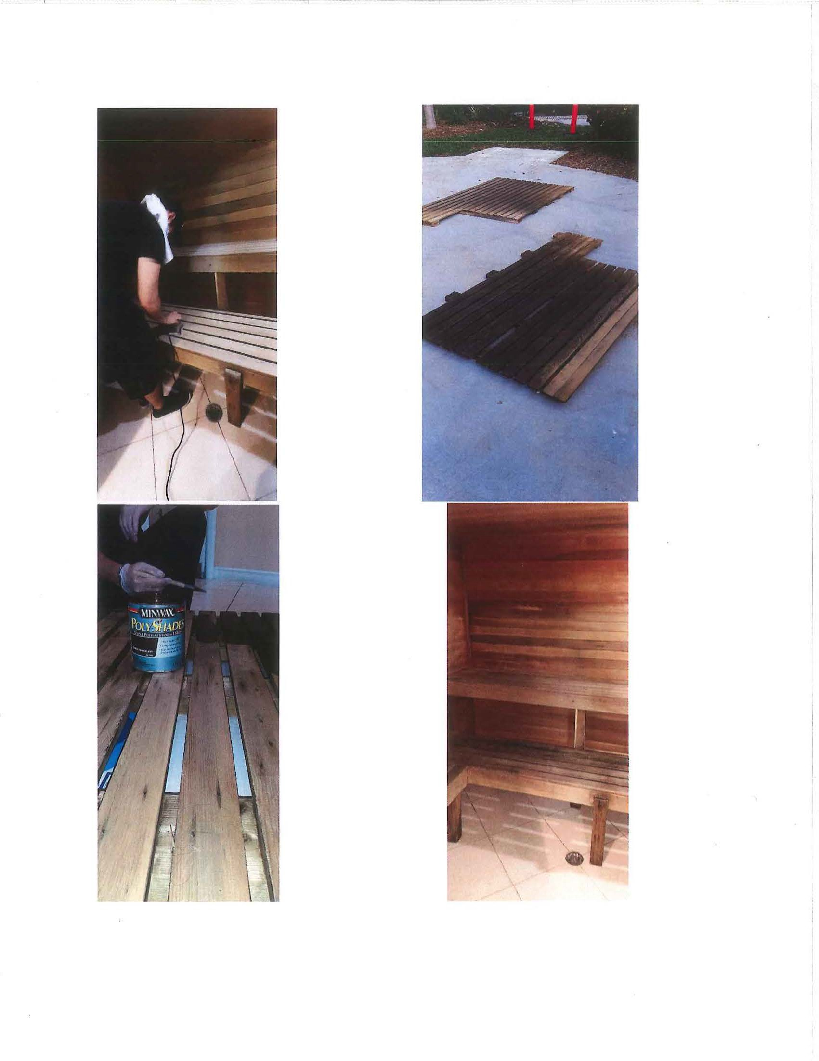

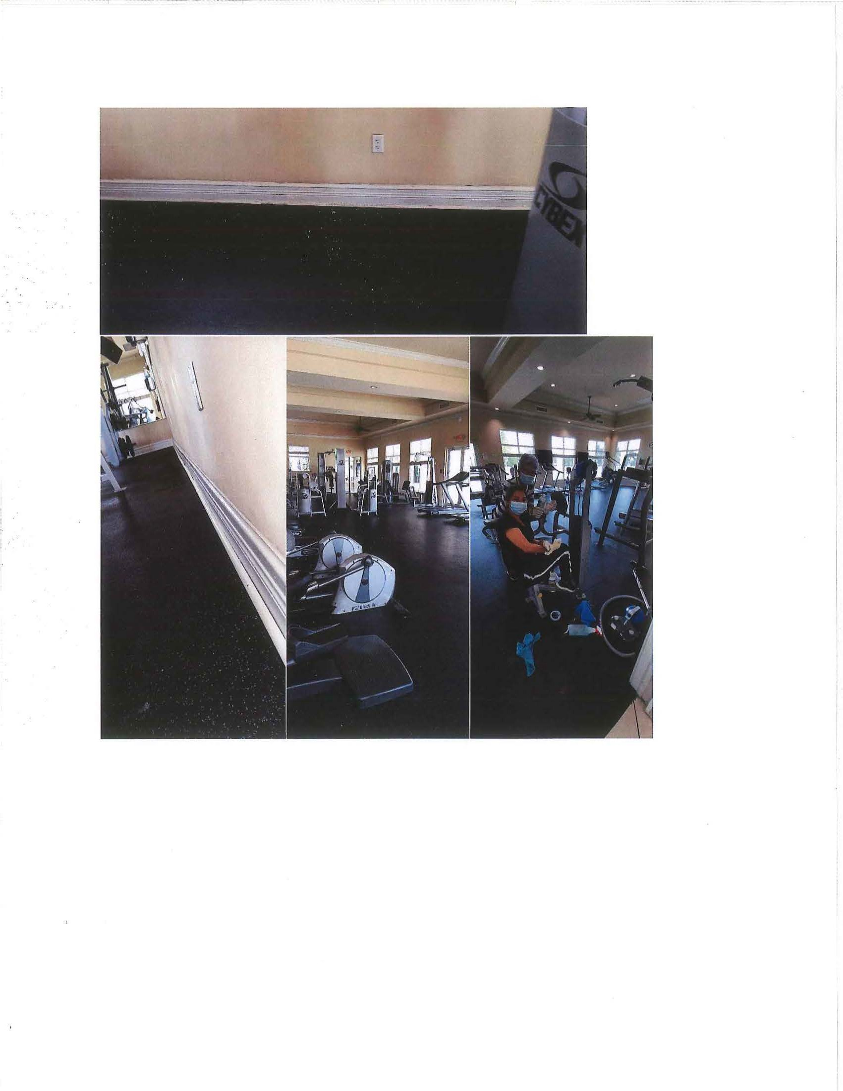

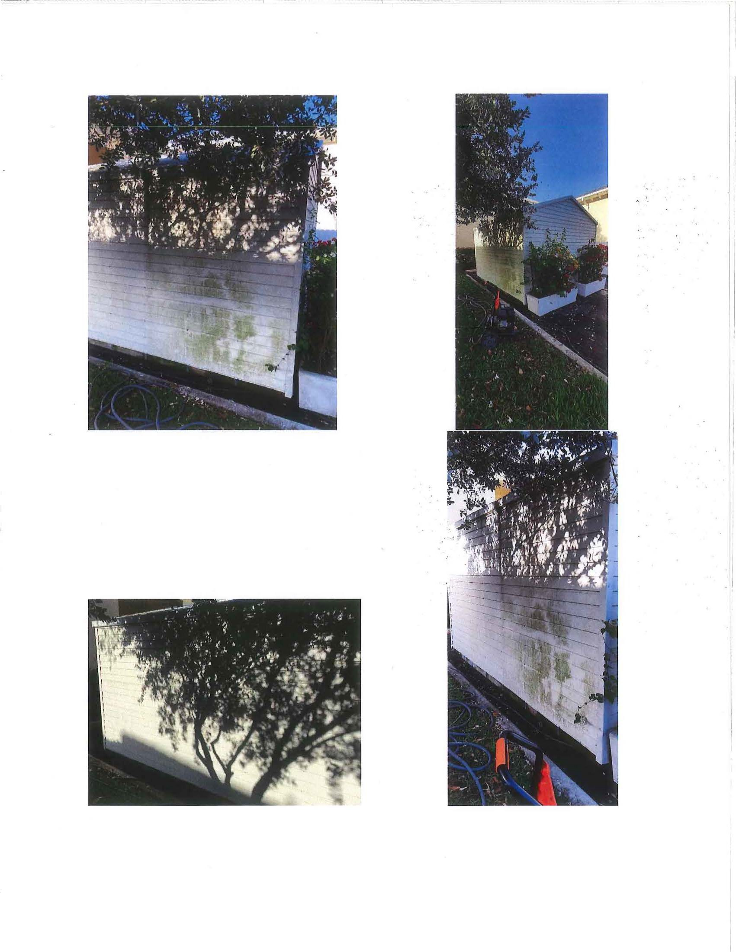



BrightView
Landscape Services

Proposal for Extra Work at Oasis - East Homestead CDD
Page 1 ofB

Property Name Property Address
Oasis - East Homestead COD 128 SE 28th Terrace Homestead, FL 33033
Contact To
Billing Address
Luis Hernandez
East Homestead COD (Oasis) 5385 N Nob Hill Rd
Sunrise,FL 33351

Project Name Clubhouse Enhancements Revised w/out Parking Lot Exit Enhancement

Project Description Landscape enhancements located at Entry,Parking lot, front of bldg. and median across CH Door
Scope of Work

QTY UoM/Size Material/Description Unit Price Total
. ,..., .....,........................ ............................, ......,......., ,..,. ................................................, , ...
Parking Lot Entry Subtotal $83.25

1.00 LUMP SUM Removal of Plant Material (Blaze) including disposal fees $46.25 $46.25

1.00 LUMP SUM Installation of Bromeliads (relocate from existing $37.00 $37.00 landscape)
Parking Lot NW corner Subtotal $739.95

1.00 | LUMP SUM | Removal of Pentas, Jamaican Croton, & Ruella | $111.00 |  | $111.00
1.50 | PALLET | Sod | $419.30 |  | $628.95
Ruella Bed in | Parking Lot |  |  | Subtotal | $796.45
1.0 0 | LUMP SUM | Removal & Disposal of Ruella | $92.50 |  | $92.50
1.50 | PALLET | Sod | $419.30 |  | $628.95
1.00 | LUMP SUM | Stump Removal | $75.00 |  | $75.00
Perimeter Hedge Subtotal $197.98
8.00 | EACH | 3 Gallon lxora | $24.75 | $197.98
Parking Lot NE Corner Subtotal $456.30
1.00 | LUMP SUM | Removal of Jamaican Croton & Pentas | $37.00 | $37.00
1.00 | PALLET | Sod | $419.30 | $419.30
Parking Lot SECorner Subtotal $875.60
1.00 | LUMP SUM | Removal of Croton & Pentas | $37.00 | $37.00
2.00 | PALLET | Sod | $419.30 | $838.60
Median Front of C.House Doors Subtotal $638.97

1.00 LUMP SUM Removal of GIF, Mussaenda, Chanel, (2) Purple $111.00 $111.00

$40.70
 |  | Bush/Tree
2.00 | EACH | 3 Gallon Dracaena Colorama | $20.35
2.00 | BAG | Mexican Pebble | $33.99
1.00 | PALLET | Sod | $419.30

$67.97
. $419.30

Parking Lot Green island ficus Subtotal $141.83

1.00 | LUMP SUM | Removal of Green Island Ficus | $37.00 | $37.00
0.25 | PALLET | Sod | $419.30 | $104.83

BrightView
l.MdKwpes.,,,4c:•f

Proposal for Extra Work at Oasis - East Homestead CDD
Page 2 of6

West Front of Clubhouse

1.00 LUMP SUM

1.50 PALLET
Front of Cl ubhouse

  - LUMP SUM
 |  | (2) purple bush/tree
62.00 | EACH | 3 gallon F'n Tea | $10.72 | $664.54
8.00 | EACH | 3 Gallon Rojo Congo | $17.14 | $137.11
1.00 | PALLET | Sod | $419.30 | $419.30
Images

Subtotal $739.95

Removal of Green Island Ficus, Trinette, Croton, (2) $111.00 $111.00 Cypress trees, ginger, Podocarpus (up to Green fence)
Sod $419.30 $628.95
Subtotal $1,516.95

Removal of Mussaenda, Podocarpus, (3) Cypress trees & $296.00 $296.00

CHS CH4
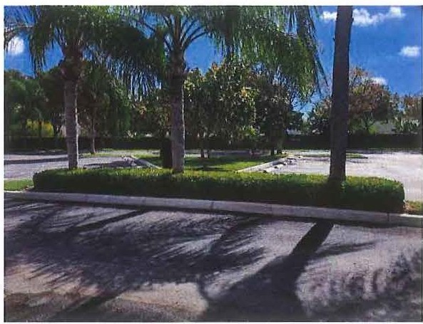

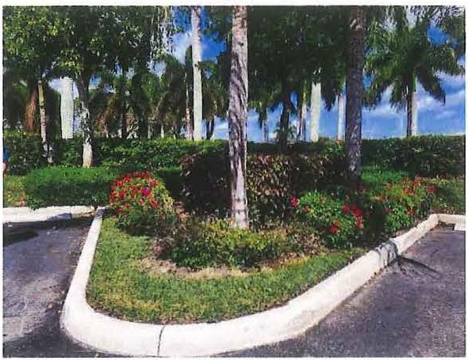

BrightView
UlldtupeStrvk.

Proposal for Extra Work at Oasis - East Homestead COO
Page 3 016

CH9 CHS

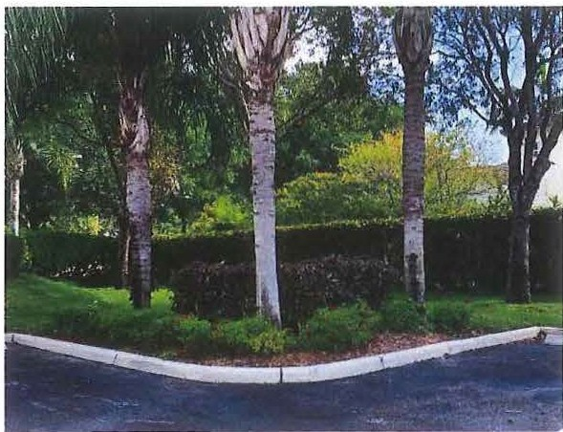

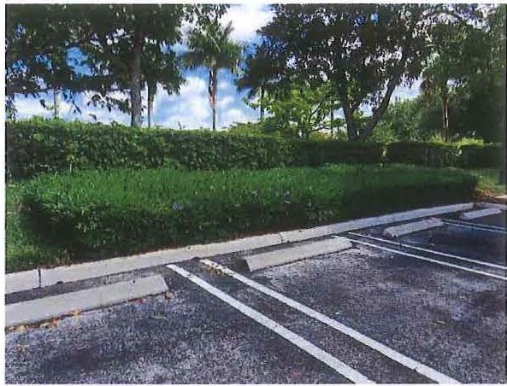

CH7 CH Front
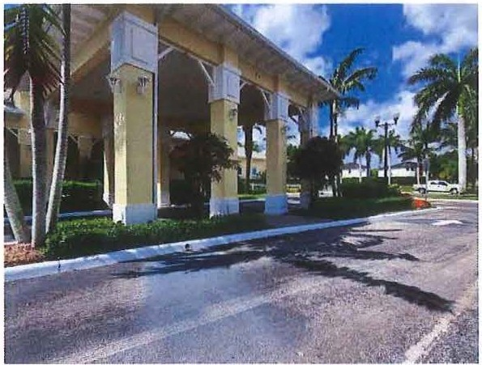

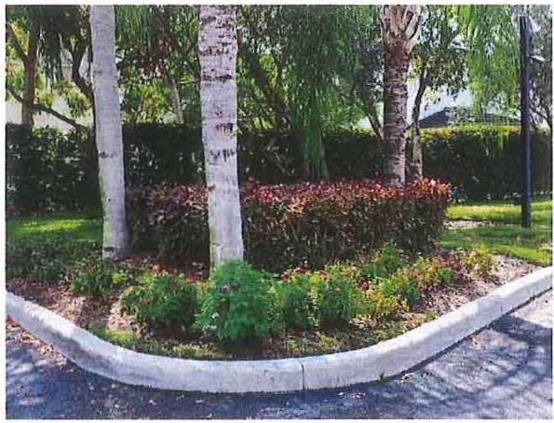

uncfK•SeMal1
Proposal for Extra Work at Oasis - East Homestead CDD

CH CH Rail
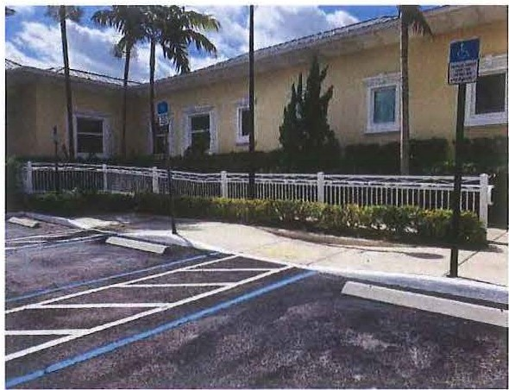

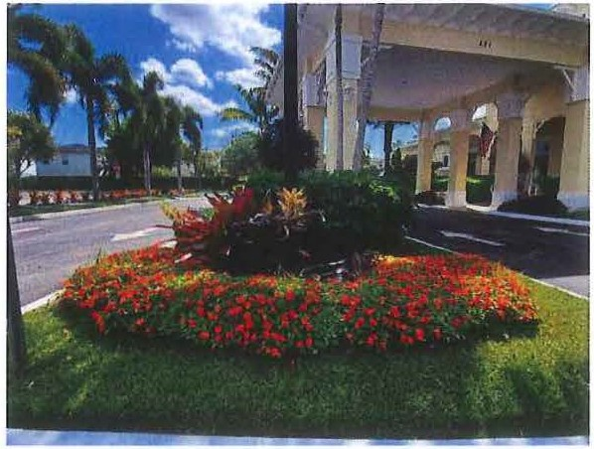

CH3 CH2
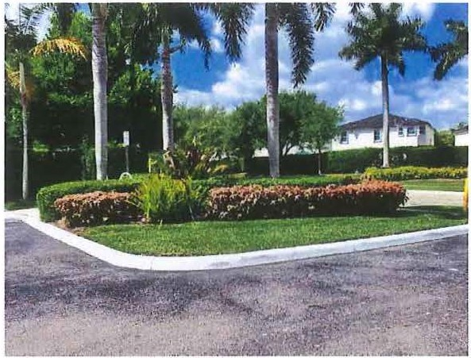

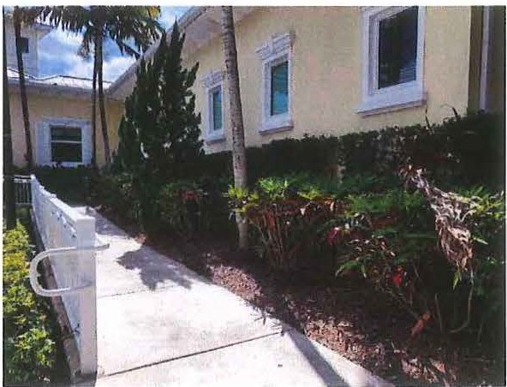

BrightView
Undscape Servku

Proposal for Extra Work at Oasis - East Homestead CDD
Page 5 of 6

CH 1
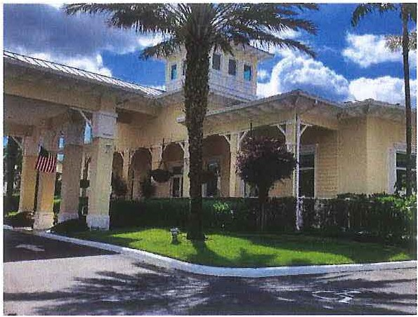

ForInt ernal use only
SO# | 7192648
JOB# | 352 1000 30
Service Line | 130 | Total Price | $6,187.23

Page 6 of 6

TERMS & CONDITIONS
    - The Contractor shall recognize and perform in accordance with written terms, written specifications and dra'Nings only, contained or referred to herein, All materials shall conform to bid specifications.

    - Work Forco: Contractor shall designate a qualified representative with experience In landscape maintenance/construction upgrades or when applicable In tree management. The workforce shall be competent and qualified, and shall be legally authorized to work In the U.S.

    - License and Penmils: Contractor shall maintain a Landscape Contractors license, ij required by Slate or local law, and will comply with all other license and permit requirements of the City, State and Federal Governments, as well as all other requirements of law.

    - Taxes: Contractor agrees to pay all applicable taxes, Including sales tax where applicable on material supplied.

    - Insurance: Contractor agrees to provide General Liability Insurance, Automotive Uabmty Insura n ce, Worker's Compensation Insurance, and any other Insurance required by law or ClienV OWner, as specified in writing prior to commencement of work. if not specified, Contractor will furnish insurance with
$1,000,000limit of liability.

    - Llablllty: Contractor shall Indemnify the CllenVOwner and its agents and employees from and against any th ird party liabilities that arise out of Contractor's work to the extent such liabilities are adjudicated to have been caused by Contractor's negligence or vallful misconduct. Contractor shall not
be liable for any damage that occurs from Acts of God are defined as those caused by '11-'indstorm, hail, fire flood, earthquake, hurricane and freezing, etc. Under these circumstances, Contractor shall have the right to renegotiate the terms and prices of this agreement within sixty (60) days. Any Illegal trespass, claims and/or damages resulting from work requested that is not on property owned by ClienVOwner or not under ClienVOwner management and control shall be the sole responsibility of the Client/Owner.
1

    - Subcontrac1ors: Contractor reserves the right to hire qualified subcontractora to perform specialized functions or work requiring specialized equipment.

14, Cancellation: Notice of Cancellation of work must be received ln writing before the crew Is dispatched to their location or Client/Owner will beliable for a minimum travel charge of $150.00 and billed to CllenVOwner.

The foll owing sections shall apply where Contractor provides Customer with tree care services:

- Tree & Stump Removal: Trees removed will be cut as dose to the ground as possi ble based on conditions to or nextto the bottom of the tree trunk. Additional charges will be levied for unseen hazards such as, but not limited to concrete brick filled trunks, metal rods, etc. If requestedmechanical grinding of visible tree stump will be done to a defined 1'1dth and depth below ground level at an additional charge to lhe Client/Owner. Defined backfill and landscape material may be specified. CllenVOwner shallbe responsible for contacting Underground Service Alert to locateunderground utility lines prior to start of work. Contractor is not responsible damage done to underground utilities such as but not limited to, cables, wires, plpes and irrigation parts. Contractor will repair damagedi rrigation lines at the Cli enVOWner s expense.
1

- Waiver of Llabllity: Requests for crown thinning in excess of twenty-five percent (25%) or work not In accordance with ISA (International Society of Arborlcullural) standards will require a signedwaiver of liability.

Acceptance of this Contract
Contractor is authorized to perform the work stated on the face of this Contract. Payment will be 100% due at time of billing. If payment has not been received by BrightView within fifteen (15) days aner billing, BrlghtVlew shall be entitled to all costs of collection, including reasonable attorneys' fees and it shall be relieved of any obligation to continue performance under this or any other Contract with CllenVOwner. Interest at a per annum rate of 1.5% per month (18% per year), or the highest rate
permitted by law, may be charged on unpaid balance 30 days aner billing.

NOTICE: FAILURE TO MAKE PAYMENT WHEN DUE FOR COMPLETED \/\ORK ON CONSTRUCTIONJOBS, MAY RESULT IN A MECHANIC'S LIEN ON THE TITLE TO YOUR PROPERTY

Custo m e r
Property Manager

8. Additional Services: Any additional work not shown In the above specifications involving extra costs will be executed only upon signed written
S ignatur e
Tlllo

ordera, and will become an extra charge over and above the estimate.

8. Access to Jobsile: Client/OWner shall provide all utilities to perform the work. ClienVOWner shall furnish access to all parts of jobsite vmere Contractor Is to perform work as required by the Contract or other functions related thereto, during normal business hours and other reasonable periods of time. Contractor will perform the work as reasonably practical after the owner makes
Luis Hernandez April16,2020
Dale

BrightView Landscape Services, Inc. "BrightView"
Account Manager, Senior

the site available for performance of the work.
Slgnalu,e
TiUe

- Invoicing: Client/Owner shall make payment to Contractor within fineen (15) days upon receipt of Invoice. In the event the schedule for the completion of th e work shall require more than thirty (30) days, a progress bill will be presented by month end and shall be paid within fifteen (15) days upon receipt of Invoice.
Vincent Fernandez April 16, 2020
Printed Name

- Termination: This Work Order may be terminated by the either party with or without cause, upon seven (7) work days advance written notice. CllenVOwner v.ill be required to pay for all materials purchased and work completed to the date of termination and reasonable charges Incurred In demobilizing.

U. Assignment: The OWner/Client and the Contractor respectively , bind themselves, their partners, successors, assignees and legal representative to the other party with respect to all covenants ol this Agreement. Neither the OMl er/Client nor the Contractor shall assign or transfer any Interest in this Agreement without the written consent of the other provided, however, that consent shall not be requri ed to assign this Agreement to any company which controls, Is controlled by, or Is under common control with Contractor or in connection vAth assignment to an affiliate or pursuant to a merger, sale of all or substantially all of Its assets or equity securities, consolidation, change of control or corporate reorganization.

13. Disclaimer: This proposal was estimated and priced based upon a site visit and visual Inspection from ground level using ordinary means, at or about the time this proposal was prepared. The price quoted in this proposal for the work described, Is the result of that ground level visual Inspection and therefore
our company will not be liable for any additional costs or damages for additional work not described herein, or liable for eny incidents/accidents resulting from conditions, that were not ascertainable by said ground level
visual Inspection by ordinary means at the time said inspection was performed. Contractor cannot be held responsbi le for unknown or otherwise hidden defects. Any corrective work proposed herein cannot guarantee exact results. Professional engineering, architectural, and/or landscape design services ("Design Services") are not included in this Agreement and shall not be
provided by the Contractor. Any design defects In the Contract Documents are the sole responsibility of the OWner. If the ClienV Owner must engage a licensed engineer, architect and.for l andscape design professional, any costs
concerning these Design Services are to be paid by the Client/OWner directly to the designer invotved.
Job#: SO#
352100030
7192648
Proposed Price: $6,187.23

FASTSIGNS.
More than fast. More than signs
FASTSIGNS - Cutler Bay
19740 S. Dixie Hwy. Cutler Bay, FL 33157

Estimate
Estim ate Date:
Page 1 of 4

542 - 6610

3/27/2020 2:48:30PM

ph: 305.232.0259
fax: 305.232.0269
Email: 542@fastsigns.com
Printed: 3/27/2020 3:02:02PM

Customer: Contact: Description:
East Homestead COD
Alexandra Garcia Customer: Updated ADA signage and Parking Lot Signs Package

2880
ph: (786) 349-1580

Sales Person: Lukas Aldama Clerk: Lukas Aldama
cell: (786) 348-4395
email: oasisld@nfcamenity.com

Dear Alexandra:

Thank you for calling FASTSIGNS of Cutler Bay. A quotation for the signage we discussed follows. If you have any questions, please call me at (305) 232-0259 or by email at 542@fas tsigns.com. I look forward to working together.

Sincerely,

Lukas Aldama
Product Qty Sides J HxW Unit Cost Totals

Vinyl HxW 2 17 X 24
Descriptio n: Printed or complex cut vinyl priced by H x W - White vinyl lettering
$25.50
Includes Discount:

($17.00)
$51.00

Color: White
Text: "Please Dry Off..."

2 DiBond 3mm
Description: DiBond 3mm with cut or printed vinyl applied - Plotted black vinyl lettering ontop - rounded corners
10x 36 $46.10
Includes Discount:

($8.13)
$46.10

Color: Text:
White
Authorized Personnel ONLY

3 DiBond 3mm 2 24 X 18 $42.29 $84.57
Description: DiBond 3mm with cut or printed vinyl applied - Plotted black Includes Discount: ($14 .93) vinyl letteringontop - rounded comers
Color: White
Text: ATTENTION
(ICON)
Pedestrian
Crosswalk

4 DiBond 3mm 2 1 24 X 18 $42.29 $84.57
Description: DiBond 3mm with cut or printed vinyl applied - Plotted black Includes Discount: ($14.93) vinyl lettering ontop - rounded corners
Color: White
Text: ATTENTION
This parking
Lot is closed...

5 DiBond 3mm 3 24 X 18 $39.19 $117.56
Description: DiBond 3mm with cut or printed vinyl applied - Plotted black Includes Discount: ($20.75) vinyl lettering ontop - rounded corners

SYSTEMIFASTSIGNS_CRYSTAL_Estlma te01

More than fast. More than signsm.

FASTSIGNS
More than fast. More than signs
FASTS IGNS - Cutler Bay
19740 S. Dixie Hwy. Cutler Bay, FL 33157

Estimate
Estimate Date:
Page 2 of 4

542 - 6610

3/27/2020 2:48:30PM

ph: 305.232.0259
fax: 305.232.0269
Email: 542@fastsigns.com
Printed: 3/27/2020 3:02:02PM

Color: Text:

White Handicap Walkway
Product Qty Sides I H x W Unit Cost Totals

- DiBond 3mm 4 36 X 10
Description: DiBond 3mm with cut or printed vinyl applied - Plotted black vinyl lettering ontop - rounded corners
$33.28
Includes Discount: ($18.15)
$133.10

Color: White
Text: Emergency Walkway

- DiBond 3mm 3 5.5 X 7
Description: Brushed DiBond 3mm with cut or printed vinyl applied - horizontal grain with printed clear graphic ontop
$12.43
Includes Discount: ($4.15)
$37.30

Color: Text:
White
Premises are protected by Envera Systems

- DiBond 3mm 2 2 X 3.5
Description: Brushed DiBond 3mm with cut or printed vinyl applied - horizontal grain with printed clear graphic ontop
$12.50
Includes Discount: ($11.82)
$25.00

Color: White
Text: Please Ring Bell

- DiBond 3mm • 2
Description: Brushed DiBond 3mm with cut or printed vinyl applied - horizontal grain with printed clear graphic ontop
2 X 3.5 $12.50
Includes Discount: ($11.82)
$25.00

Color: White
Text: Please Keep Gate Closed
10 ADA Signage • 12 11 X 8 $68.45 $821.35
Description: Custom routed dimensional ADA sign age - Comb ination sign made up of Black 1/8" ADA Rowmark with bright white tactile lettering and brushed silver (horizontal grain) dibond backers. To be stuck to the wall with Hibond tape strips on the back
Text: ADA Signage with various verbiage: "Accessible" - QTY: 6
"Res troom" - QTY: 4 "Women" - QTY: 1
"Men" - QTY: 1
TOTAL - 12 Signs

11 ADA Signage • 6 6.5 X 8 $74.51 $447.03
Description: Custom routed dimensional ADA signage - Combination sign made up of Black 1/8" ADA Rowmark with bright white tactile lettering and brushed silver (horizontal grain) dibond backers. To be stuck to the wall with Hibond tape strips on the back
SYSTEMIFASTSIGNS_CRYSTAL_Estlmale01

Emali: 542@fastsigns.com
Product Qty Sides I HxW Unit Cost Totals Text: ADA Signage with various verbiage:
"No Smoking" - QTY: 6

- DiBond 3mm 9 4 X 12
Description: Brushed DiBond 3mm with cut or printed vinyl applied - horizontal grain with printed clear graphic ontop
Color: Black onWhite
Text: 1 of ea GrandRoom
Conference Room Fire Alarm Remote...
Pool Equipment Room... Mechanical Room...

$16.87
Includes Discount:

($21.61)

$151.83

4 ea
Keep door closed

- DiBond 3mm
Desc ription : Brushed DiBond 3mm with cut or printed vinyl applied - horizontal grain with printed clear graphic ontop
Color: Black on White
T ext: Loading Dock
6 X 12 $18.40
Includes Discount:

($12.00)
$18.40

- Engraved surface - 1/16
De sc ription : Engraved plastic - 1/16" thickness
Text: 1 of ea
Fire Alarm Remote....
Foyer 185 Persons Max
2 3.5 X 12 $47.38 $94.75

- Set-Up Fee
Description: Copy and/or layout set-up fee - Artwork and Files
1 X 1 $90.00 $90.00

- Installation
D esc ription: Installation of signs - RTA Vinyl on 2doors, various signs with HiBond Tape - DOES NOT _INCLUDE ANY U CHANNEL POLES OR INSTALLATION OF THEM
***PRICE IS PENDING INSTALLATION DETAILS FROM
CLIENT***
****PRICE SUBJECT TO CHANGE****

1 X 1 $550.00 $550.00

Notes:

SYSTEM\FASTSIGNS_CRYSTAL_Esrtnlate01

Email: 542@fastsigns.com
- Custo m orders and/or orders produced per customer's specifications are non-refundable. ' Orders under $500 require prepayment in full.
Line Item Total: | $2,777.56
Tax Exempt Amt: | $2,777.56
Subtotal: | $2,777.56
Taxes: | $0.00
Total: | $2,777.56
Deposit Required: | $2,777.56

- Orders over $500 require a 50% deposit

Bill To: East Homestead COD Alexandra Garcia
171 NE 30TH RD
Homestead, FL 33033
Payment is due upon placement of the order.

Received/Accepted By:
I I

SYSTEMIFASTSIGNS_CRYSTAL_Esllmate01

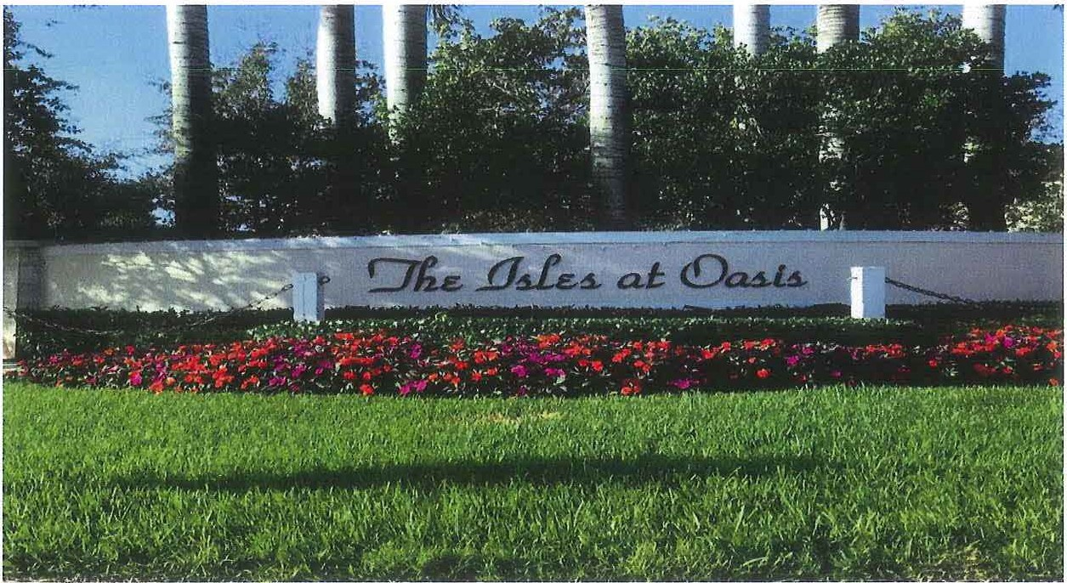

EAST HOMESTEAD CDD

FIELD REPORT

Oovernmeni.t


Gh4S
M.l\f\•9•m•n1 •.,.I<••

Meeting April 27, 2020
Governmental Management Services-South Flo.-ida, LLC 5385 N. Nob Hill Road Sunrise, FL 33351

{ISLES AT THE OASIS)
Chris Segui CSegui@gmssf com
Cell Phone II 305-906-2654

Landscaping
  - Brightview (BV) provided scheduled services during the month of March and the estimated timetable for services that will be provided in April, Attachment A.
Lakes
  - Lake Management services was provided by Eco-Blue Aquatic. Service was performed on March 11 and March 14, 2020 as indicated by the vendor. Next service will be provided on April 20 and April 27, 2020. Service Report, Attachment 8.

FERTILIZATION
  - Antillean entryway palms treated for fun gus.
  - Belize palms treated for nutritional deficiencies.
  - Treated ant piles throughout property.
  - Clubhouse and Pacific Blvd. treated for weeds.
  - Treated weeds on 147 Ave. Followed up the following week.
  - Preventive treatment on flower beds and trees on Mediterranean and Pacific Blvd.
  - 2 turf weed treatments around lake banks.
  - Treated 21 royal palms that showed sig ns of palm scale.
  - Treated golden shower tree on 152 Ave.

MISCELLANEOUS
  - The work on the water fountains for Lake 3 (between Atlantis and Cari bbean) and Lake 9 (between Bali and Mirage) have been completed, fount ains are currently working.

  - The District is going to start working on the water fountains for Lake 1 between (Barbados and Atlantis) and Lake 2 between (Capri and Barbados).
Governmental Management Services-South Florida, LLC 5385 N. Nob Hill Road Sunrise, FL 33351

- The bench near Atlantis in front of Lake 3 that was vandalized with graffiti, it was cleaned by the District.
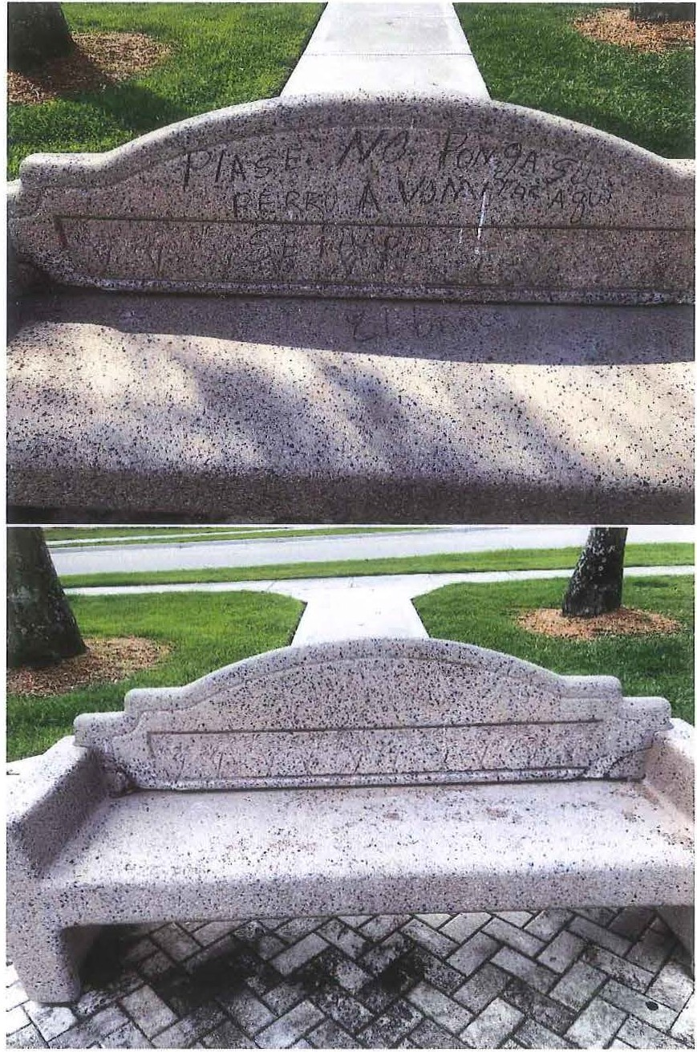

Govem mental Management Services-South Florida, LLC 5385 N. Nob Hill Road Sunrise, FL 33351

- The District has the gym expansion exhibits organized and is pending for the City of Homestead to reopen again to submit for them for the final approval.

Governmental Management Services-South Florida, LLC 5385 N. Nob Hill Road Sunrise, FL 33351

4 1 P a g e



Oasis

Sunday Monday Tuesday Wednesday Thursday Friday Saturday
2 3 4

s ---

----
6
Mowing

7 8 9 10
Trimming Trimming
Herbicide Herbicide

--- 11

--- --
;.·:

12 13 14 15 16 17 rn I
Mowing
Trimming Trimming Trimming Trimming
. I
hith:Ft rtitiu?: I Herbicide Herbicide --- - ---
19 20 21 22 23 24 25

26 27 28 _{I} 29
Mowing
- -- - -
30

Irrigation Irrigation
Irrigation

AQUATICSERVICES, INC,
(305} 316-1817

SERVICE & INSPECTION REPORT
ecoblueaquatic@gmail.com

CUSTOMER: East Homestead COD
DATE: 3/11/2020
WEATHER CONDITIONS: Sunny

WATER TESTING (COMBINED AVERAGE)

1 Hi gh r.· Average !... Low

TEMPERATURE H 20 :
70.7°F

r High r. Average r Low

DISSOLVED OXYGEN: 6.1
Ph READING: 6.3 r High r.- Average r Low
r Hi gh r.' Average r· Low

WATER CLARITY: Good
WATER LEVEL: Good
C' High 1 Average r.· Low

LAKE MANAGEMENT
W ALGAE CONTROL

6,7,8,9, 10





l GRASSES & EMERGENTS Num b er s of lake worked SUBMERSED AQUATICS 6,7,8,9 ,10
FLOATING PLANTS 6,7,8,9,10
DEBRIS 6,7,8,9,10

We apply a treatment to eliminate aquat ic weeds and algaegrowt h. We also removed the garbageIn the lakes.

{305) 316-1817
B ecoblueaquatic@gmail.com

FISH & WILDLIFE ORSERVATION
Bass r Bream r Catfish Tilapia r Grass carp P M osqui to fish

FISH:

BIRDS:

REPTILES:
Duck r Wood strok Shorebird r Wading bird P' Songbird r Gallinuele
r Alligator r Snake Turtle r Lizard 1 Amphi bian s Insects



NATIVE PLANTS NOTED
I Cypre s I Wax myrtler FLp ine r Red maple r Mangrove 1 Pond apple r Oak
1 Cocopl um Bulrush I Blueflagiris P Arrowhead 1 Thalia 1 Palm Pl cker el weed
1 Spickerush r Buttonbush r Eelgrass 1 Cordgrass r Spatterdock I Ferns I Fakahatcheegrass
1 Baby tears 1 Naiad r Chara 1 Duckweed I Bacopa r Pondweed 1 Bladdewort INVASIVE & EXOTIC PLANTS NOTED
r Me l al euca I Pennywort J Bischifia 1 Shoebutton 1 Sedge 1 Australi an pine
1 Brazi li an peper 1 Earl eaf acacia 1 Climbingfern r Torpedograss
1 Air potato 1 Azolla 1 Salvinla r Pri mros e r Hydrllla 1 Cattail r Floating hearts
1 Water lettuce 1 Water hyacinth 1 All igatorweed r Hygrophil a We saw ducks and other native birds.

(305) 316-1817

SERVICE & INSPECTION REPORT
WATER TESTING (COMBINED AVERAGE) TEMPERATURE H2O: 70.7°F DISSOLVED OXYGEN: 6.1
Ph READING; 6.3
ecob/ueaquatic@gmail.com

CUSTOMER; East Homestead CDD
DATE: 3/14/2020
WEATHER CONDITIONS; Sunnv

WATER CLARITY: Good

WATER LEVEL: Good

c- High r Average C:- Low
r | High | ti' Average | r | Low
1 | High | r. Average |  | C Low
r  C | High  High | r. Average  !i' Average |  | <" Low  r Low

LAKE MANAGEMENT

ALGAE CONTROL

r GRASSES & EMERGENTS

1,2,3,4,5

Numb e r s of lake worked

SUBMERSED AQUATICS

1,2,3,4,5

FLOATING PLANTS 1,2,3,4,5

DEBRIS

1,2,3,4,5



We apply a treatment to eliminate aquatic weeds and algae growth. We also removed the garbage in the lakes.

ECO-BLUE


AQUATIC SERVICES, IN C.

{305} 316-1817

ecoblueaquatlc@gmall.com

FISH & WILDLIFE ORSERVATION

l;1 Bass I Bream 1 Catfish l;1 Tl l apia I Grass carp rv' Mosquito fish

FISH:

BIRDS:

REPTILES:
Ii! Duck r Wood strok W Shorebird I Wading bird l;1 Songbird r Galllnuele
1 Alligator 1 Snake W Turtle 1 Lizard 1 Amphibians l;1 Insects

NATIVE PLANTS NOTED
I Cypress 1 Wax myrtle 1 Flplne I Red maple 1 Mangrove r Pond apple 1 Oak
I Cocoplum W Bulrush 1 Blue flag iris IY' Arrowhead r Thalia , - Palm P- Pickerelweed
r Splckerush I Buttonbush 1 Eelgrass 1 Cordgrass I Spatterdock 1 Ferns r Fakahatcheegrass
1 Babytears 1 Naiad 1 Char a 1 Duckw eed 1 Bacopa 1 Pondweed P- Bladdewort

INVASIVE & EXOTIC PLANTS NOTED

1 Melaleuca I Pennywort 1 Blschifia 1 Shoebutton 1 Sedge 1 Australian pine
1 Brazilian peper 1 Earleafaca,cia 1 Climbingfern 1 Torpedograss
r Air potato 1 Azolla 1 Salvlnia r Primrose 1 Hydrilla r Cattail 1 Floatinghearts
1 Water lettuce r Water hyacinth 1 Alligatorweed l Hygrophlla We saw ducks and other native birds.

■ADSU&M
JGRLOUIP

INVOICE

Mr. Luis Hernandez
East Homestead Community Development District 5385 N. Nob Hill Road
Sunrise, FL 33351

Invoice No: Date:

Client I Project:

0908-010
04-01-20

via E-Mail: LHernandez@gmssf.com (954) 582-2864
Oasis Clubhouse Gym Expansion 171 NE 3oth Road.
Homestead, FL 33033

PER IOD COVERED:

March 2020

SERVICES PROVIDED:

Hours:

Jose Viana 3.5 hours@ $250.00 / hour

Total Fees Total Expenses

$ 875.00

$ 875.00
$ 0.00

TOTAL AMOUNT DUE
$ 875.00

Adsum Group, LLC
Tax ID: 20-4444617

Make all checks payable to Adsum Group, LLC Payment is due within 30 days from date of invoice
If you have any questions concerning this invoice, please contact Jose Viana I 305.562.8096 I Jviana@AdsumGroup.com

Adsum Group, LLC 9727 SW 142nd PL
Miami, FL 33186
Off: (305) 577-9949
Fax: (305) 577-9943
www.AdsumGroup.com

El www.A dsum Gr oup.com

DETAILS OF SERVICES PROVIDED
East Homestead Commun ity Development District

Date Initials Descript ion Hours

Cha rges for Jose Viana

03/05/20  03/23/20 | JV  JV | Meeting with Chris Segui to review MDC Fire approved sheets on permit sets and reorganized sets for the City of Homestead. Identified missing pages.  Reviewed approved County Fire revisions and | 1.0  2.0
 |  | prepared summary for Homestead. Sent email to
 |  | Chris, Luis and George with update.
03/27/20 | JV | Emails with Paula, Luis and Chris regarding electronic | 0.5
 |  | resubmission of permit revisions to the Building
 |  | Department of the Cit y of Homestead during
 |  | coronavirus emergency since Building Dept is closed
 |  | to the public for in-person visits.
 |  | SUB-TOTAL JV (Rate =$250/ hr) | 3.5
 |  |  | $ 875.00
 |  | TOTAL TIME, HOURS | 3.5
 |  | TOTAL TIME, COST | $ 875.00
I EXPENSES I |  | Courier/ Maili ng / Permit Fee | $
 |  | Printing | $
 |  | Parking | $
 |  |  | $
 |  | Adm in Cost 15% | $
 |  | SUB-TOTAL EXPENSES | $
 |  | GRAND TOTAL (TIM E PLUS EXPENSES) | $ 875.00

PAYMENT TERMS: 30 DAYS FROM INVOICE DATE

(Jose Vta11a
Jose Viana Adsum Group, LLC

Page 2 of 2

EAST HOMESTEAD
COMMUNITY DEVELOPMENT DISTRICT

Summary of Invoices
April 27, 2020

Fund | Date | Check No.s | Amount
General | 3/10/20 | 3170-3184 | $ 71,905.38
General | 3/24/20 | 3185-3196 | $ 104,975.40
General | 4/10/20 | 3197-3216 | $ 133,289.40
Total Invoices for Approval |  |  | $ 310,170.18

CHECK VEND# .....INVOICE........EXPENSED TO... VENDOR NAME DATE DATE INVOICE YRMO DPT ACCT# SUB SUBCLASS
STATUS
AMOUNT ....CHECK.....
AMOUNT #

3/10/20 00002

3/10/20 00107
1/31/20 160809 202001 310-51300-31500
LEGAL FEES THRU 01/31/20
BILLING, COCHRAN, LYLES, MAURO
3/01/20 41132 202003 320-57200-45300
POOL SVCS/CHEM INCL 3/20
3/01/20 | 41132 202003 320-57200-45303  SPLASH KIDS SVC | * | 500.00
3/03/20 | 41327 202003 320-57200-45301 | * | 450.00

* 2,824.50
2,824.50 003170
- - - - - - - - - - - - - - -
* 3,550.00

FOUNTAIN ACID WASH/TREAT

BLUE MAGIC POOL SERVICES

4,500.00 003171
- - - - - - - - - - - - - - -

6633374 201912 320-53800-46205
3/10/20 | 00145 | 12/11/19
3/10/20 | 00033 | 2/25/20
3/10/20 | 00034 | 2/26/20

PALM & HARDWOOD TRIMMING
BRIGHTVIEW LANDSCAPE SERVICES,INC.
16834147 202002 310-51300-32200
SVCS 02/2020
CARR RIGGS & INGRAM
022020 202002 320-53800-43000
SVCS 0l/23-02/24/20
2/26/20 | 022020 202002 320-57200-43000  SVCS 01/23-02/24/20 | * | 5,183.87
2/26/20 | 022020 202002 320-57200-43100  SVCS 01/23-02/24/20 | * | 211.35
2/26/20 | 022020 202002 320-57200-43200 | * | 548.90

* 17,020.00
17,020.00 003172
-
- - - - - - - - - - - - - -
* 5,000.00
5,000.00 003173
-
- - - - - - - - - - - - - -
* 3,362.00

SVCS 01/23-02/24/20

CITY OF HOMESTEAD

9,306.12 003174
- - - - - - - - - - - - - - -

0791174- 202003 320-57200-41005
3/10/20 | 00065 | 2/28/20
3/10/20 | 00026 | 3/01/20
3/10/20 | 00061 | 2/03/20

SVCS 03/08-04/07/20
COMCAST
3352 202003 320-53800-46800
MAINT 03/2020
ECO BLUE AQUATIC SERVICES, INC.
687723 202003 320-57200-34505
MONITORING 03/01-03/31/20
3/10/20 | 00003 | 2/25/20 | 6-938-35 202002 310-51300-42000 | * | 25.91
 |  | 3/03/20 | 6-945-79 202002 310-51300-42000 | * | 28.97

* 261.59
261.59 003175
-
- - - - - - - - - - - - - -
* 906.67
906.67 003176
- - -
- - - - - - - - - - - -
* 2,466.85

DELIVERIES THRU 02/20/20 DELIVERIES THRU 2/21/20
ENVERA SYSTEMS

FEDEX
2,466.85 003177
- - - - - - - - - - - - - -
-

54.88 003178

EH EAST HOME SROSINA

CHECK VEND# .....INVOICE........EXPENSED TO... VENDOR NAME
DATE |  | DATE
3/10/20 | 00018 | 2/28/20
3/10/20 | 00009 | 3/01/20

INVOICE YRMO DPT ACCT# SUB SUBCLASS
0098373- 202002 310-51300-31100
SVCS 02/06/20
STATUS

*
AMOUNT ....CHECK.....
AMOUNT #
47.50

353
FORD ENGINEERS, INC.
202003 310-51300-34000
- - - - - - - - - -
* 3,688.25
47.50 003179

MGMT FEES 03/2020
3/01/20 | 353  RENT | 202003 310-51300-44000 | * | 200.00
3/01/20 | 353 | 202003 310-51300-35100 | * | 83.33

3/01/20
3/01/20
3/01/20
COMPUTER TIME
353 202003 310-51300-31300
DISSEMINATION AGENT SVCS
353 202003 320-53800-49300
WEBSITE ADMINISTRATION
353 202003 310-51300-51000
OFFICE SUPPLIES
3/01/20 | 353  POSTAG | 202003 310-51300-42000  E AND DELIVERIES | * | 17.90
3/01/20 | 353  COPIES | 202003 310-51300-42500 | * | 158.90
3/01/20 | 353 | 202003 310-51300-41000 | * | 13.16

* 312.50
* 208.33
* 20.00

TELEPHONE
 |  | 3/01/20
 |  | 3/01/20
 |  | 3/01/20
 |  | 3/01/20
3/10/20 | 00161 | 1/23/20
3/10/20 | 00054 | 1/23/20
 |  | 3/03/20
3/10/20 | 00184 | 3/02/20

354 202003 320-53800-34000
FIELD SVCS 03/2020
355 202003 300-20700-10200
DISSEMINATION AGT SVC3/20
355 202003 700-51700-73000
DISSEMINATION AGT SVC3/20
355 202003 700-13100-10000
DISSEMINATION AGT SVC3/20
GOVERNMENTAL MANAGEMENT SERVICES -
INV-0222 202003 320-57200-34000 MGMT FEES 03/20
NFC AMENITY MANAGEMENT
27754 202001 320-53800-46001
EMERGENCY SVC CALL
27792 202003 320-57200-46000
REPAIRS/MAINT

* 2,847.33
* 104.17
* 104.17
* 104.17-
7,653.87 003180
- - - - - - - - - - - - - - -
* 17,614.00
17,614.00 003181
-
- - - - - - - - - - - - - -
* 1,800.00
* 2,000.00

ORTIZ CONSTRUCTION SERVICES
524128 202003 320-57200-46000
NEW EMERGENCY LIGHT
- - - - - - - - - -
* 80.25
3,800.00 003182

SAN ROMAN SERVICE INC. 80.25 003183

EH EAST HOME SROSINA

NOTICE OF MEETING
CHECK DATE | VEND# | .....INVOICE........EXPENSED TO...  DATE INVOICE YRMO DPT ACCT# SUB SUBCLASS |  |  |  |  | VENDOR | NAME | STATUS | AMOUNT | ....CHECK.....  AMOUNT #
3/10/20 | 00097 | 3/02/20 | 59116  SUPPLIES | 202003 | 320-57200-46000  UNIVERSAL | FIRE |  | * |  | 369.15 | 369.15 | 003184
3/24/20 | 00005 | 3/17/20 | I0000463 202003 |  | 310-51300-48000 | * |  |  |  | 143.92

ALM MEDIA, LLC

143.92 003185

3/24/20 00072
3/05/20 0020446- 202003 320-57200-41000
SVCS 03/05-04/04/20
* 312.38

AT&T 312.38 003186

3/24/20 | 00145 | 2/01/20 | 6685639 202002  MAINT 02/2020 | 320-53800-46200 | * | 22,688.58
 |  | 2/01/20 | 6685639 202002  MAINT 02/2020 | 320-57200-46200 | * | 2,392.50
 |  | 3/01/20 | 6725891 202003  MAINT 03/2020 | 320-53800-46200 | * | 22,688.58
 |  | 3/01/20 | 6725891 202003  MAINT 03/2020 | 320-57200-46200 | * | 2,392.50
 |  | 3/17/20 | 6754013 202003 | 320-57200-46201 | * | 559.33

CLBHSE PARK/LOT BROMELIAD 3/17/20 6754014 202003 320-57200-46201
CLBHSE - CLOSING IN BEDS
* 6,063.30

3/24/20 00087
BRIGHTVIEW LANDSCAPE SERVICES,INC.
3/09/20 263350 202003 320-57200-46000 *
ANN FIRE ALARM TEST/CERT

150.00
56,784.79 003187

CHI ALARMS, INC. 150.00 003188

REFUND DEPOSIT&RENTAL FEE
3/24/20 | 00129 | 3/03/20 | INV-0334 202003 320-57200-52000 JANITORIAL SUPPLIES |  |  | * | 796.65
 |  | 3/04/20 | INV-0335 202003 320-57200-52000 JANITORIAL SUPPLIES  EZ CLEANING | SUPPLIES, | LLC | * | 129.75 | 926.40 003189
3/24/20 | 00003 | 3/10/20  3/17/20 | 6-952-84 202003 310-51300-42000  DELIVERIES THRU 03/03/20  6-958-95 202003 310-51300-42000  DELIVERIES THRU 03/6/20 |  |  | *  * | 17.87  13 6. 23
 |  |  | FEDEX |  |  |  |  | 154.10 003190
3/24/20 | 00185 | 3/24/20 | 032020 202003 300-36200-10200 |  |  | * | 650.00

JENNIFER GLASS

650.00 003191

EH EAST HOME SROSINA

FINAL PYMT-FLOAT FOUNTAIN
CHECK DATE | VEND# | .....INVOICE..... ...EXPENSED TO...  DATE INVOICE YRMO DPT ACCT# SUB SUBCLASS |  |  | VENDOR NAME | STATUS | AMOUNT | ....CHECK.....  AMOUNT #
3/24/20 | 00161 | 3/22/20 INV-0230 202003 320-57200-52000 REIMB - AMAZON PURCHASES  NFC AMENITY |  |  | MANAGEMENT | * | 568.64 | 568.64 003192
3/24/20 | 00054 | 3/18/20 | 27810  FINAL | 202003 320-53800-60000  PYMT-FLOAT FOUNTAIN | * |  | 17,100.00
 |  | 3/18/20 | 27811  FINAL | 202003 320-53800-60000  PYMNT-ELEC F/FOUNTA | * |  | 13,200.00
 |  | 3/18/20 | 27812 | 202003 320-53800-60000 | * |  | 9,298.50

ORTIZ CONSTRUCTION SERVICES

39,598.50 003193

3/24/20 00095

3/24/20 00067

3/24/20 00054
3/18/20 13609 202003 320-57200-60001
3 MONTEREY UMBRELLA 9FT
ROBERTS ALUMINUM FURNITURE
3/10/20 S0105847 202003 320-57200-52000 SUPPLIES
3/20/20 S0106045 202003 320-57200-52000 SUPPLIES
SPECTRUM PAINT CENTER
3/17/20 27814 202003 320-57200-46000
50% DEPOSIT
 |  | ORTIZ CONSTRUCTION SERVICES |  |  | 4,143.16 | 003196
4/10/20 00107 | 4/01/20 | 41405 202004 320-57200-45300 | * | 3,550.00
 |  | POOL SVCS CHEM INCL 04/20
 | 4/01/20 | 41405 202004 320-57200-45303  SPLASH KIDS SVC | * | 500.00
 |  | BLUE MAGIC POOL SERVICES |  |  | 4,050.00 | 003197
4/10/20 00145 | 3/27/20 | 6779641 202003 320-53800-35000 | * | 1,350.00
 |  | IRRIGATION REPAIRS
3/27/20 |  | 6779642 202003 320-57200-46201  CLBHSE CLS BEDS ADD'L SOD | * | 1,458.30
3/31/20 |  | 6785875 202002 320-53800-46210  ADD'L TREE CARE 02/20 | * | 1,998.33
3/31/20 |  | 6785876 202003 320-53800-46210  ADD'L TREE CARE 03/20 | * | 1,998.33
4/01/20 |  | 6764956 202004 320-53800-46200 | * | 22,688.58

* 1,125.00

* 123.29
* 295.22

* 4,143.16

1,125.00 003194

418.51 003195

MAINT 04/20
4/01/20 6764956 202004 320-57200-46200
MAINT 04/20

* 2,392.50

BRIGHTVIEW LANDSCAPE SERVICES,INC. 31,886.04 003198

EH EAST HOME SROSINA

CHECK VEND# .....INVOICE........EXPENSED TO... VENDOR NAME DATE DATE INVOICE YRMO DPT ACCT# SUB SUBCLASS
4/10/20 00087 4/01/20 263571 202004 320-57200-34500
UL ANNU.CERT 5/20-4/2021
STATUS AMOUNT ....CHECK.....
AMOUNT #
* 540.00

- - - - - - - - - - - - - - - - - - - - - - - - - -
CHI ALARMS, INC.
540.00 003199

4/10/20 00034 3/27/20 032020 202003 320-53800-43000
SVCS 03/2020
3/27/20 | 032020 202003  SVCS 03/2020 | 320-57200-43000 | * | 5,119.67
3/27/20 | 032020 202003  SVCS 03/2020 | 320-57200-43100 | * | 359.09
3/27/20 | 032020 202003 | 320-57200-43200 | * | 694.74

* 3,266.09

SVCS 03/2020

CITY OF HOMESTEAD

9,439.59 003200

4/10/20 00065

4/10/20 00064

4/10/20 00092
3/28/20 0791174- 202004 320-57200-41005
SVCS 04/08-05/07/20
COMCAST
3/19/20 14231 202003 320-57200-34501
SECURITY SVC 3/06-3/19/20
DELTA FIVE SECURITY
4/10/20 04102020 202004 300-20700-10200
TXFER OF TAX RCPTS
* 295.32

* 626.00

* 11,518.98

295.32 003201

626.00 003202

4/10/20 00125

4/10/20 00180

4/10/20 00026

4/10/20 00061
EAST HOMESTEAD CDD C/O WELLS FARGO
4/10/20 04102020 202004 300-20700-10200 *
TXFER OF TAX RCPTS
EAST HOMESTEAD CDD C/O US BANK
4/10/20 04102020 202004 300-20700-10200 *
TXFER OF TAX RCPTS
EAST HOMESTEAD CDD C/O US BANK
4/01/20 3388 202004 320-53800-46800 *
MAINT 04/2020
ECO BLUE AQUATIC SERVICES, INC.
3/01/20 688582 202004 320-57200-34505 *
MONITORING 04/01-04/30/20

19,723.64

5,187.85

906.67

2,466.85
11,518.98 003203

19,723.64 003204

5,187.85 003205

906.67 003206

4/10/20 00003
ENVERA SYSTEMS
3/31/20 6-972-90 202003 310-51300-42000
DELIVERIES THRU 03/25/20

* 17.39
2,466.85 003207

FEDEX 17.39 003208

EH EAST HOME SROSINA

4/10/20 00009
CHECK DATE | VEND# | .....INVOICE........EXPENSED TO...  DATE INVOICE YRMO DPT ACCT# SUB SUBCLASS | VENDOR | NAME | STATUS | AMOUNT | ....CHECK.....  AMOUNT #
4/10/20 | 00018 | 12/13/19 0097971- 201912 310-51300-31100  SVCS THRU 12/13/2019 |  |  | * | 1,187.50
 |  | 3/27/20 0098547- 202003 310-51300-31100  SVCS THRU 03/27/20  FORD ENGINEERS, INC. |  |  | * | 142.50 | 1,330.00 003209

4/01/20

356

202004 310-51300-34000

- - - - -

MGMT FEES 04/2020

4/01/20
356
RENT
202004 310-51300-44000

4/01/20
4/01/20
356 202004 310-51300-35100
COMPUTER TIME
356 202004 310-51300-31300
DISSEMINATION AGT SVCS

4/01/20 356 202004 320-53800-49300
WEBSITE ADMINISTRATION 4/01/20 356 202004 310-51300-51000
OFFICE SUPPLIES
4/01/20 |  |  | 356 202004 310-51300-42000 |  | * | 36.60
4/01/20 |  |  | 356  COPIES | 202004 310-51300-42500 | * | 104.30
4/01/20 |  |  | 356 | 202004 320-53800-52000 | * | 2,217.00
4/01/20 |  |  | STORAGE SHED LAKE#3 & #9  357 202004 320-53800-34000  FIELD SVCS 04/2020 |  | * | 2,847.33
4/01/20 |  |  | 358 202004 300-20700-10200 |  | * | 104.17
 |  |  | DISSEMINATION AGTSVC 4/20
4/01/20 |  |  | 358 202004 700-51700-73000  DISSEMINATION AGTSVC 4/20 |  | * | 104.17
4/01/20 |  |  | 358 202004 700-13100-10000 |  | * | 104.17-
DISSEMINATION AGTSVC 4/20
GOVERNMENTAL MANAGEMENT SERVICES -
- - - - - - - - - -
4/10/20 | 00161 | 4/01/20 | INV-0225 202004 320-57200-34000 |  | * | 17,614.00
MGMT FEES 04/2020
NFC AMENITY MANAGEMENT
- - - - - - - - - -
4/10/20 | 00136 | 4/09/20 | 4092020 202004 320-57200-52000 |  | * | 935.00
 |  |  | INSTAL | L NEW CAMERAS/CABLE  OSNETWORK LLC | - - | - - - - - - - -
4/10/20 | 00063 | 4/09/20 | 04092020 202004 320-57200-52000 |  | * | 179.63
 |  |  | REIMB | PURCHASES  CASH

POSTAGE AND DELIVERY

9,821.96 0-03210
- - - - -

17,614.00 003211
- - - - -

935.00 003212
- - - - -

179.63 003213

* | - | - | - - | - | - - - - -  3,688.25
* |  |  |  |  | 200.00
* |  |  |  |  | 83.33
* |  |  |  |  | 312.50
* |  |  |  |  | 208.33
* | 20.15

EH EAST HOME SROSINA

CHECK VEND# ...·..INVOICE........EXPENSED TO... VENDOR NAME DATE DATE INVOICE YRMO DPT ACCT# SUB SUBCLASS
STATUS
AMOUNT ....CHECK.....
AMOUNT #

4/10/20 00176

4/10/20 00067

4/10/20 00017
3/25/20 03252020 202003 320-53800-46203
PEST CNTRL & FERT 03/20
SOUTHERN PLANT AND PEST SERVICES
3/31/20 80106281 202003 320-57200-52000
SUPPLIES
4/03/20 80106364 202004 320-57200-52000
SUPPLIES
SPECTRUM PAINT CENTER
3/25/20 5688168 202003 310-51300-32300
TRUSTEE FEES
3/25/20 5689309 202003 310-51300-32300
TRUSTEE FEES
* 4,000.00
4,000.00 003214
- - - - - - - - - - - - - - -
* 1,077.00
* 88.76
1,165.76 003215
- - - - - - - - - - - - - - -
* 4,040.63
* 7,544.09

U.S. BANK 11,584.72 003216

TOTAL FOR BANK A TOTAL FOR REGISTER
310,170.18
310,170.18

EH EAST HOME SROSINA

1. Recap of Capital Project Fund Activity Through March 31, 2020
Opening Balance in Construction Account | 2006A | $8,519,403.00
 | 2006B | $23,039,700.90
Source of Funds: Interest Earned | 2006A | $103,245.16
 | 2006B | $1,187,181.20
lnterfund Transfer In | 2006A | $30,225.69
 | 2006B | $90,257.98
Use of Funds:  Disbursements: Land |  | ($11,859,028.02)
Earthwork/Demolition |  | ($7,333,763.86)
Survey |  | ($329,457.81)
Storm Drain |  | ($2,244,976.53)
Water/Sewer |  | ($5,468,187.03)
Permits |  | ($715,057.16)
Lift Stations |  | ($566,512.68)
Force Main |  | ($210,299.54)
Pavement |  | ($380,407.75)
Guardrail |  | ($22,949.20)
Irrigation |  | ($67,278.62)
Maint Bond |  | ($107,427.05)
Concrete |  | ($387,025.85)
Lighting |  | ($252,948.44)
Lakes |  | ($51,886.24)
Landscaping |  | ($1,718,522.14)
Entrance |  | ($504,497.35)
Cost of Issuance |  | ($737,368.10)
Adjusted Balance in Construction Account at March 31, 2020 |  | $12,420.66

- Funds Available For Construction at March 31, 2020
Book Balance of Construction Fund at March 31, 2020 $12,420.66

- Investments - US Bank
March 31, 2020 Construction Fund:

IY2g
Overnight

Yield 0.010%

Maturity

Principal
$12,420.66

ADJ: Outstanding Requisitions $0'.00-
BaIanceat 03/31/2020 =====$=1=2=,4=20=.6=6=

1. Recap of Capital Project Fund Activity Through March 31, 2020  Opening Balance in Construction Account | $11,129,398.95
Source of Funds: Interest Earned | $22,519.67
lnterfund Transfer In | ($3,739.57)
Use of Funds:
Disbursements: Clubhouse Purchase | ($9,017,616.57)
Public ROW Improvements | ($345,024.79)
Lake Fountains | ($66,463.50)
Clubhouse Improvements | ($616,220.67)
Clubhouse Equipment | ($185,695.86)
Miscellaneous | ($23,302.00)
Cost of Issuance | ($525,059.63)
Adjusted Balance in Construction Account at March 31, 2020 | $368,796.03

- Funds Available For Construction at March 31, 2020
Book Balance of Construction Fund at March 31, 2020 $368,796.03

- Investments - Wells Fargo Bank
March 31, 2020
, Construction Fund: Overnight

Yield 0.010%

Due Maturity

Principal
$368,796.03

ADJ: Deposit/Prepaid $0.00
ADJ: Outstanding Requisitions $-0.0-0
BaIance at 03/31/2020 ======$3=68=,796.03

1. Recap of Capital Project Fund Activity Through March 31, 2020
Opening Balance in Construction Account | $5,264,915.45
Source of Funds: Interest Earned | $8,210.45
lnterfund Transfer In | ($6.61)
Use of Funds:
Disbursements: Roadways Improvements | ($350,987.01)
Stormwater Management System | ($2,828,841.90)
Water Distribution | ($741,290.66)
Sewage Collection System | ($1,042,795.25)
Softcost | ($4,972.00)
Miscellaneous | $0.00
Cost of Issuance | ($298,539.46)
Adjusted Balance in Construction Account at March 31, 2020 | $5,693.01

- Funds Available For Construction at March 31, 2020
Book Balance of Construction Fund at March 31, 2020 $5,693.01

- Investments - US Bank
March 31, 2020
Construction Fund: Overnight

Yield 0.010%

Maturity

Principal
$5,693.01

ADJ: Deposit/Prepaid $0.00
\DJ: Outstanding Requisitions '-$0-.0-0
BaIanceat 03/31/2020 ======::::::::::$:5:,:6=9=3=.0=1==

EAST HOMESTEAD COMMUNITY DEVELOPMENT DISTRICT
Special Assessment Receipts
Fiscal Year 2020

$1,435,112.40 |  |  |  |  |  |  |  |  | $854,398.07 | $1,462,962.92 |  | $384,798.83 | $4,137,272.22
ASSESSED THROUGH COUNTY |  |  |  |  |  |  |  |  |  | ASSESSED THROUGH COUNTY
34.69% |  |  |  |  |  |  |  |  | 20.65% | 35.36% |  | 9.30% | 100.00%
 |  |  |  |  |  |  |  | 001.300.36300.10000 | 023.700.36300.10000 |  | 024.700.36300.10000 | 025.700.36300.10000
 | DATE | DESCRIPTION | GROSS AMOUNT | DISC/PENALTY | COMMISSIONS | INTEREST | NET RECEIPTS | O&M Portion | 2013A DSF Portion |  | 2015A DSF Portion | 2019A DSF Portion | Total
 | 11/22/19 | 11/01/19-11/08/19 | $159,984.66 | $6,514.55 | $1,534.70 | $0.00 | $151,93S.41 | $52,702.45 | $31,376.55 |  | $53,725.22 | $14,131.19 | $151,935.41
 | 12/03/19 | 11/09/19-11/14/19 | $121,767.46 | $4,870.74 | $1,168.97 | $0.00 | $115,727.75 | $40,142.95 | $23,899.22 |  | $40,921.99 | $10,763.59 | $115,727.75
 | 12/10/19 | 11/15/19-11/30/19 | $3,0Sl,686.51 | $122,068.36 | $29,296.18 | $0.00 | $2,900,321.97 | $1,006,046.45 | $598,952.49 |  | $1,025,570.30 | $269,752.74 | $2,900,321.97
 | 12/20/19 | 12/01/19-12/13/19 | $316,101.18 | $12,313.61 | $3,037.86 | $0.00 | $300,749.71 | $104,322.27 | $62,108.55 |  | $106,346.80 | $27,972.09 | $300,749.71
 | 01/10/20 | 12/14/19-12/31/19 | $92,457.88 | $2,701.32 | $897.58 | $0.00 | $88,858.98 ' | $30,822.87 | $18,350.48 |  | $31,421.04 | $8,264.58 | $88,858.98
 | 01/30/20 | INTEREST | $0.00 | $0.00 | $0.00 | $2,021.34 | $2,021.34 | $701.15 | $417.43 |  | $714.76 | $188.00 | $2,021.34
 | 02/10/20 | 0l/01/20-01/31/20 | $81,880.93 | $1,628.27 | $802.52 | $0.00 | $79,450.14 | $27,559.19 | $16,407.44 |  | $28,094.02 | $7,389.49 | $79,450.14
 | 03/09/20 | 02/0l/20-02/29/20 | $S6,885.18 | $543.13 | $563.42 | $0.00 | $55,778.63 | $19,348.16 | $11,518.98 |  | $19,723.64 | $5,187.85 | $55,778.63
 | 04/10/20 | 03/01/20-03/31/20 | $75,079.54 | $11.39 | $750.69 | $D.00 | $74,317.46 | $25,778.80 | $15,347.48 |  | $26,279.08 | $6,912.11 | $74,317.46
 |  | TOTAL | $3,955,843.34 | $150,651.37 | $38,051.92 | $2,021.34 | $3,769,161.39 | $1,307,424.30 | $778,378.61 |  | $1,332,796.84 | $350,561.63 | $3,769,161.39 I
 |  |  |  |  |  |  |  |  |  |  |  |  | Gross Collected
 | Assessed on Roll: |  |  |  |  |  |  |  |  |  |  |  | 95.61%
 |  | GROSS AMOUNT |  | ASSESSMENTS | ASSESSMENTS | AMOUNT
ASSESSED PERCENTAGE COLLECTED TRANSFERRED TO BETFR.
O&M |  | $1,435,112.40 | 34.6874% | $1,307,424.30 | ($1,307,424.30) | $0.00
DEBT SERVICE 2013A |  | $854,398.07 | 20.6512% | $778,378.61 | ($751,616.33) | $26,762.28
DEBT SERVICE 2015A |  | $1,462,962.92 | 35.3606% | $1,332,796.84 | ($1,286,794.13) | $46,002.71
DEBT SERVICE 2019A |  | $384,798.83 | 9.3008% | $350,561.63 | ($338,461.67) | $12,099.96
TOTAL $4,137,272.22 100.00% $3,769,161.39 ($3,684,296.43) $84,864.96 I

 | TRANSFERS TO DEBT SERVICE:
DATE | CHECK# | 2013A | 2015A | 2019A
11/26/2019 | 3060/3061/3062 | $0.00 | $53,725.22 | $14,131.19
 | DISSEMINATION | $625.02 | $0.00 | $0.00
12/23/2019 | 3090/3091/3092 | $684,960.25 | $1,172,839.09 | $308,488.41
2/12/2020 | 3146/31473148 | $49,623.62 | $32,135.80 | $8,452.58
2/28/2020 | 3162/3163/3164 | $16,407.44 | $28,094.02 | $7,389.49
Amount due: | TOTAL | $751,616.33 | $1,286,794.13 | $338,461.67
Amount due: | TOTAL | $26,762.28 | $46,002.71 | $994,335.17

EAST HOMESTEAD
COMMUNITY DEVELOPMENT DISTRICT
COMBINED BALANCE SHEET
March 31, 2020
 | Major Funds  Debt Capital  General Service Projects |  |  | Total Governmental  Funds
ASSETS:
Cash | $130,935 |  |  | $130,935
Petty Cash | $500 |  |  | $500
Assessments Receivable | $25,779 | $48,539 |  | $74,317
Due from Other Funds |  | $36,326 |  | $36,326
Investment- State Board | $2,031,177 |  |  | $2,031,177
Investments:
Series 20118
Reserve B |  | $9,389 |  | $9,389
Revenue B |  | $14,629 |  | $14,629
Prepayment B |  | $38,339 |  | $38,339
Deferred B |  |  | $12,421 | $12,421
Series 2013
Reserve A |  | $402,348 |  | $402,348
Revenue A |  | $916,055 |  | $916,055
Interest A |  | $128 |  | $128
Sinking |  | $43 |  | $43
Construction A |  |  | $368,796 | $368,796
Series 2015
Reserve A |  | $138,982 |  | $138,982
Revenue A |  | $1,410,666 |  | $1,410,666
Series 2019
Reserve A |  | $179,827 |  | $179,827
Interest A |  | $3,899 |  | $3,899
Revenue A |  | $342,704 |  | $342,704
Construction A |  |  | $5,693 | $5,693
Deposits-Electric | $17,519 |  |  | $17,519

I

TOTAL ASSETS $2,205,910 $3,541,873 $386,910 $6,134,693

LIABILITIES:
Accounts Payable | $34,880 |  |  | $34,880
Due to Other Funds | $36,326 |  |  | $36,326
TOTAL LIABILITIES | $71,206 | $0 | $0 | $71,206

FUND BALANCES:
Nonspendable:
Deposits and prepaid items $17,519 $17,519 Restricted:
Debt Service |  | $3,541,873 |  | $3,541,873
Capital Projects |  |  | $386,910 | $386,910
Unassigned | $2,117,185 |  |  | $2,117,185
TOTAL FUND BALANCES | $2,134,704 | $3,541,873 | $386,910 | $6,063,487
TOTAL LIABILITIES & FUND BALANCES | $2,205,910 | $3,541,873 | $386,910 | $6,134,693

COMMUNITY DEVELOP' MENT DISTRICT GENERAL FUND
Statement of Revenues, Expenditures, and Changes in Fund Balance For the Period Ended March 31, 2020

ADOPTED PRORATED BUDGET ACTUAL
DESCRIPTION BUDGET THRU 03/31/20 THRU 03/31/20 VARIANCE

REVENUES:
Maintenance Assessments | $1,363,357 | $1,363,357 | $1,307,424 | ($55,932)
Interest Income | $20,000 | $10,000 | $13,988 | $3,988
Clubhouse Income | $10,000 | $5,000 | $10,398 | $5,398
FEMA Revenue | $0 | $0 | $500 | $500
TOTAL REVENUES | $1,393,357 | $1,378,357 | $1,332,311 | ($46,046)
EXPENDITURES:
ADMINISTRATIVE:
Supervisors Fee | $18,000 | $9,000 | $7,800 | $1,200
Fica Expense | $1,377 | $689 | $597 | $92
Engineering Fees | $10,000 | $5,000 | $6,537 | ($1,537)
Attorney Fees | $40,000 | $20,000 | $11,904 | $8,097
Annual Audit | $5,900 | $5,000 | $5,000 | $0
Trustee Fees | $18,074 | $11,585 | $11,585 | $0
Dissemination Agent | $3,750 | $1,875 | $1,875 | $0
Arbitrage | $1,800 | $900 | $0 | $900
Assessment Roll | $2,000 | $2,000 | $2,000 | $0
Management Fees | $44,259 | $22,129 | $22,130 | ($0)
Computer Time | $1,000 | $500 | $500 | $0
Telephone | $100 | $50 | $53 | ($3)
Postage | $850 | $425 | $449 | ($24)
Printing & Binding | $4,000 | $2,000 | $1,203 | $797
Rentals & Leases | $2,400 | $1,200 | $1,200 | $0
Insurance | $7,554 | $7,554 | $7,374 | $180
Legal Advertising | $1,500 | $750 | $661 | $89
Other Current Charges | $750 | $375 | $235 | $140
Website Management | $2,500 | $1,250 | $1,250 | $0
Office Supplies | $350 | $175 | $125 | $50
Dues, Licenses | $175 | $175 | $175 | $0
TOTAL ADMINISTRATIVE | $166,338 | $92,631 | $82,652 | $9,979
FIELD:
Field Management | $22,168 | $11,084 | $13,084 | ($2,000)
Parking Lot Monitoring Fees | $10,164 | $5,082 | $1,702 | $3,380
Electricity | $32,500 | $16,250 | $19,785 | ($3,535)
Landscape Maintenance | $296,000 | $148,000 | $168,492 | ($20,492)
Tree Care Services | $0 | $0 | $3,997 | ($3,997)
Landscape Materials | $30,000 | $15,000 | $47,842 | ($32,842)
Irrigation Maint & Repairs | $10,000 | $5,000 | $23,222 | ($18,222}
Janitorial Supplies | $0 | $0 | $0 | $0
Lake Maintenance | $10,000 | $5,000 | $5,440 | ($440)
Pressure Washing | $10,000 | $5,000 | $10,500 | ($5,500)
Lights Repair and Maintenance | $4,500 | $2,250 | $2,050 | $200
Monuments Maintenance/Repairs | $5,000 | $2,500 | $2,545 | ($45)
Sign/Decor Maintenance | $5,000 | $2,500 | $325 | $2,175
Stormwater Services | $20,000 | $10,000 | $0 | $10,000
Holiday Lighting | $36,000 | $18,000 | $47,192 | ($29,192)
Sidewalk Repairs | $10,000 | $5,000 | $1,900 | $3,100
Special Projects | $14,267 | $7,133 | $127,441 | ($120,308)
Off Duty Police Services | $7,200 | $3,600 | $2,566 | $1,034
Contingency | $20,000 | $10,000 | $3,010 | $6,990
TOTAL FIELD | $542,799 | $271,399 | $481,093 | ($209,693)

GENERAL FUND
Statement of Revenues, Expenditures, and Changes in Fund Balance For the Period Ended March 31, 2020

DESCRIPTION | ADOPTED BUDGET | PRORATED BUDGET THRU 03/31/20 | ACTUAL THRU 03/31/20 | VARIANCE
CLUBHOUSE
Access Control | $3,200 | $1,600 | $1,368 | $232
Active Video Monitoring | $10,223 | $5,112 | $15,967 | ($10,856)
Alarm Monitoring | $750 | $375 | $0 | $375
Air Conditioning Maint Contract | $2,400 | $1,200 | $760 | $440
Fitness Equipment Maintenance | $6,250 | $3,125 | $1,122 | $2,003
Equipment Repair | $5,000 | $2,500 | $0 | $2,500
Electric | $65,000 | $32,500 | $29,984 | $2,516
Cable/Internet Services | $4,600 | $2,300 | $1,965 | $335
Holiday Lighting | $9,730 | $4,865 | $0 | $4,865
Insurance | $30,796 | $15,398 | $30,546 | ($15,148)
Landscape Maintenance | $28,710 | $14,355 | $16,848 | ($2,493)
Landscape Replacement | $10,000 | $5,000 | $8,155 | ($3,155)
License, Music | $1,450 | $725 | $0 | $725
Irrigation Maintenance | $2,100 | $1,050 | $0 | $1,050
Office Equipment Maintenance | $500 | $250 | $0 | $250
Janitorial Supplies | $17,500 | $8,750 | $10,026 | ($1,276)
Office Supplies/Clubhouse Supplies | $2,500 | $1,250 | $0 | $1,250
Onsite Club Management Fees | $211,368 | $105,684 | $105,684 | $0
Benefits - Club Management | $0 | $0 | $0 | $0
Pest Control | $1,020 | $510 | $425 | $85
Pool & Spa Maintenance | $42,600 | $21,300 | $21,300 | $0
Pool-Splash Pad | $6,000 | $3,000 | $3,000 | $0
Pool and Spa Repairs | $10,000 | $5,000 | $9,525 | ($4,525)
Permits | $750 | $375 | $1,557 | ($1,182)
Pool Monitoring | $18,576 | $9,288 | $3,111 | $6,177
Pool Emergency Cleaning | $2,000 | $1,000 | $0 | $1,000
Repairs and Maintenance | $50,000 | $25,000 | $20,435 | $4,565
Special Events | $6,000 | $3,000 | $900 | $2,100
Security-Roving Guard | $1,750 | $875 | $0 | $875
Telephone | $4,500 | $2,250 | $2,116 | $134
Trash Collection | $6,000 | $3,000 | $3,972 | ($972)
Water & Sewer | $2,000 | $1,000 | $1,833 | ($833)
Contingency | $10,000 | $5,000 | $17,180 | ($12,180)
Replacements | $22,710 | $11,355 | $7,591 | $3,764
Capital Reserve | $37,529 | $18,764 | $5,000 | $13,764
TOTAL CLUBHOUSE | $633,512 | $316,756 | $320,372 | ($3,616)
TOTAL EXPENDITURES | $1,342,649 | $680,787 | $884,117 | ($203,330)
Excess (deficiency) of revenues
over (under) expenditures | $50,707 | $697,570 | $448,193 | ($249,377)
Net change in fund balance | $50,707 | $697,570 | $448,193 | ($249,377)
FUND BALANCE - Beginning | $0 |  | $1,686,511
FUND BALANCE - Ending | $50,707 |  | $2,134,704

DESCRIPTION |  | ADOPTED  BUDGET |  | PRORATED BUDGET  THRU 03/31/20 |  | ACTUAL  THRU 03/31/20 |  | VARIANCE
REVENUES:
Interest Income |  | $0 |  | $0 |  | $1,586 |  | $1,586
Special Assessments - Direct B |  | $59,343 |  | $34,457 |  | $34,457 |  | $0
Specia I Assessments - Prepayments |  | $0 |  | $0 |  | $180,330 |  | $180,330
TOTAL REVENUES |  | $59,343 |  | $34,457 |  | $216,373 |  | $181,916
EXPENDITURES:
Series 20118
Interest - 11/1 |  | $29,000 |  | $29,000 |  | $29,000 |  | $0
Interest - 2/1 |  | $0 |  | $0 |  | $3,353 |  | ($3,353)
Interest - 5/1 |  | $29,000 |  | $0 |  | $0 |  | $0
Special Call - 11/1 |  | $25,000 |  | $25,000 |  | $445,000 |  | ($420,000)
Special Call - 2/1 |  | $0 |  | $0 |  | $185,000 |  | ($185,000)
TOTAL EXPENDITURES |  | $83,000 |  | $54,000 |  | $662,353 |  | ($608,353)
Excess (deficiency) of revenues
over (under) expenditures |  | ($23,658) |  | ($19,543) |  | ($445,980} |  | ($426,437)
Net change in f nd balance |  | ($23,658) |  | ($19,543} |  | ($445,980} |  | ($426,437)
FUND BALANCE - Beginning |  | $23,658 |  |  |  | $508,337
FUND BALANCE - Ending |  | $0 |  |  |  | $62,357

DESCRIPTION |  | ADOPTED  BUDGET |  | PRORATED BUDGET  THRU 03/31/20 |  | ACTUAL  THRU 03/31/20 |  | VARIANCE
REVENUES:
Interest Income |  | $0 |  | $0 |  | $5,537 |  | $5,537
Special Assessments A |  | $811,678 |  | $811,678 |  | $778,379 |  | ($33,300)
TOTAL REVENUES |  | $811,678 |  | $811,678 |  | $783,916 |  | ($27,762)
EXPENDITURES:
Series 2013
Interest - 11/1 |  | $282,422 |  | $282,422 |  | $282,422 |  | ($0)
Principal - 11/01 |  | $230,000 |  | $230,000 |  | $230,000 |  | $0
Interest - 05/1 |  | $277,678 |  | $0 |  | $0 |  | $0
TOTAL EXPENDITURES |  | $790,100 |  | $512,422 |  | $512,422 |  | ($0)
Excess (deficiency) of revenues
over (under) expenditures |  | $21,578 |  | $299,256 |  | $271,494 |  | ($27,762)
OTHER FINANCING SOURCES/(USES):
Dissemination |  | ($1,250) |  | ($625) |  | ($625) |  | ($0)
Arbitrage |  | ($600) |  | ($600) |  | $0 |  | $600
Trustee Fees |  | ($3,770) |  | ($3,770) |  | $0 |  | $3,770
TOTAL OTHER FINANCING SOURCES/USES) |  | ($5,620) |  | ($4,995) |  | ($625) |  | $4,370
Net change in fund balance |  | $15,958 |  | $294,261 |  | $270,869 |  | ($23,392)
FUND BALANCE - Beginning |  | $658,320 |  |  |  | $1,062,781
FUND BALANCE - Ending |  | $674,278 |  |  |  | $1,333,650

COMMUNITY DEVELOPMENT DISTRICT
DEBT SERVICE FUND - SERIES 2015
Statement of Revenues, Expenditures, and Changes in Fund Balance For the Period Ended March 31, 2020

DESCRIPTION | ADOPTED BUDGET | PRORATED BUDGET THRU 03/31/20 | ACTUAL  THRU 03/31/20 | VARIANCE
REVENUES:
Interest Income | $0 | $0 | $4,676 | $4,676
Special Assessments A | $1,389,815 | $1,389,815 | $1,332,797 | ($57,018)
TOTAL REVENUES | $1,389,815 | $1,389,815 | $1,337,473 | ($52,341)
EXPENDITURES:
Series 2015
Interest - 11/1 | $371,738 | $371,738 | $371,738 | $0
Interest - 05/1 | $371,738 | $0 | $0 | $0
Principal - 05/01 | $655,000 | $0 | $0 | $0
TOTAL EXPENDITURES | $1,398,475 | $371,738 | $371,738 | $0
Excess (deficiency) of revenues
over (under) expenditures | ($8,660) | $1,018,077 | $965,736 | ($52,341)
Net change in fund balance | ($8,660) | $1,018,077 | $965,736 | ($52,341)
FUND BALANCE - Beginning | $499,658 |  | $641,601
FUND BALANCE - Ending | $490,998 |  | $1,607,337

COMMUNITY DEVELOPMENT DISTRICT DEBT SERVICE FUND - SERIES 2019
Statement of Revenues, Expenditures, and Changes in Fund Balance
For the Period Ended March 31, 2020

DESCRIPTION |  | ADOPTED  BUDGET |  | PRORATED BUDGET  THRU 03/31/20 |  | ACTUAL  THRU 03/31/20 |  | VARIANCE
REVENUES:
Interest Income |  | $0 |  | $0 |  | $2,099 |  | $2,099
Special Assessments A |  | $365,559 |  | $365,559 |  | $350,562 |  | ($14,997)
Special Assessments - Prepayments |  | $0 |  | $0 |  | $0 |  | $0
TOTAL REVENUES |  | $365,559 |  | $365,559 |  | $352,661 |  | ($12,898)
EXPENDITURES:
Series 2019
Interest - 11/1 |  | $184,135 |  | $184,135 |  | $184,135 |  | ($0)
Interest - 05/1 |  | $132,577 |  | $0 |  | $0 |  | $0
TOTAL EXPENDITURES |  | $316,711 |  | $184,135 |  | $184,135 |  | ($0)
Excess (deficiency) of revenues
over (under) expenditures |  | $48,847 |  | $181,424 |  | $168,526 |  | ($12,898)
Net change in fund balance |  | $48,847 |  | $181,424 |  | $168,526 |  | ($12,898)
FUND BALANCE - Beginning |  | $188,541 |  |  |  | $370,004
FUND BALANCE - Ending |  | $237,388 |  |  |  | $538,530
 | COMMUNITY DEVELOPMENT DISTRICT
 | Long Term Debt Report
 | FY 2020
 | Series 2011B, Special Assessment Bonds
Interest Rate; | 7.25%
Maturity Date: | 5/1/2021
Bonds outstanding - 9/30/2019 |  | $800,000.00
Less: | November 1, 2019 (Special Call) | ($445,000.00)
 | Febuary 1, 2019 (Special Call) | ($185,000.00)
Current Bonds Outstanding |  | $170,000.00

Series 2013, Special Assessment Bonds
Interest Rate: | 4.125%
Maturity Date: | 11/1/2023 | $1,250,000.00
Interest Rate: | 5.00%
Maturity Date: | 11/1/2033 | $3,555,000.00
Interest Rate: | 5.625%
Maturity Date: | 11/1/2043 | $5,965,000.00
Bonds outstanding - 9/30/2019 |  | $10,770,000.00
Less: | November 01, 2019 (Mandatory) | ($230,000.00)
Current Bonds Outstanding |  | $10,540,000.00

 | Series 2015, Special Assessment Bonds
Interest Rate: | 3.750%
Maturity Date: | 5/1/2020 |  | $655,000.00
Interest Rate: | 4.25%
Maturity Date: | 5/1/2025 |  | $3,705,000.00
Interest Rate: | 4.750%
Maturity Date: | 5/1/2036 |  | $11,820,000.00
Bonds outstanding - 9/30/2019 |  |  | $16,180,000.00
Less: | May 1, 2020 (Mandatory) |  | $0.00
Current Bonds Outstanding |  |  | $16,180,000.00
 | Series 2019, Special Assessment Bonds
Interest Rate: |  | 3.550%
Maturity Date: |  | 11/1/2020 | $95,000.00
Interest Rate: |  | 3.75%
Maturity Date: |  | 11/1/2024 | $415,000.00
Interest Rate: |  | 4.125%
Maturity Date: |  | 11/1/2029 | $625,000.00
Interest Rate: |  | 4.75%
Maturity Date: |  | 11/1/1939 | $1,725,000.00
Interest Rate: |  | 5.000%
Maturity Date: |  | 11/1/2049 | $2,770,000.00
Bonds outstanding - 9/30/19 |  |  | $5,630,000.00
Current Bonds Outstanding |  |  | $5,630,000.00
ITotal Current Bonds Outstanding $32,s20,ooo.oo 1
Statement of Revenues, Expenditures, and Changes in Fund Balance For the Period Ended March 31, 2020

DESCRIPTION
ADOPTED BUDGET
PRORATED BUDGET THRU 03/31/20
ACTUAL
THRU 03/31/20 VARIANCE

REVENUES:
Interest Income | $0 | $0 |  | $79 |  | $79
TOTAL REVENUES | $0 |  | $0 |  | $79 |  | $79
EXPENDITURES:  Capital Outlay A | $0 |  | $0 |  | $0 |  | $0

TOTAL EXPENDITURES $0 |  |  | $0 |  | $0 | $0
Excess (deficiency) of revenues  over (under) expenditures $0 |  |  | $0 |  | $79 | $79
Net change in fund balance | $0 |  | $0 |  | $79 |  | $79
FUND BALANCE - Beginning | $0 |  |  |  | $12,341
FUND BALANCE - Ending | $0 |  |  |  | $12,421

DESCRIPTION
ADOPTED BUDGET
PRORATED BUDGET THRU 03/31/20
ACTUAL
THRU 03/31/20 VARIANCE

REVENUES:

Interest Income | $0 | $0 |  | $2,340 |  | $2,340
TOTAL REVENUES  EXPENDITURES: | $0 |  | $0 |  | $2,340 |  | $2,340
Capital Outlay A | $0 |  | $0 |  | $0 |  | $0

TOTAL EXPENDITURES $0 $0 $0 $0

Excess (deficiency) of revenues
over (under) expenditures $0 $0 $2,340 $2,340

Net change in fund balance |  | $0 | $0 | $2,340 | $2,340
FUND BALANCE - Beginning |  | $0 |  | $366,456
FUND BALANCE - Ending |  | $0 |  | $368,796

DESCRIPTION
ADOPTED BUDGET
PRORATED BUDGET THRU 03/31/20
ACTUAL
THRU 03/31/20 VARIANCE

REVENUES:

Interest Income | $0 | $0 |  | $36 |  | $36
TOTAL REVENUES | $0 |  | $0 |  | $36 |  | $36
EXPENDITURES:
Capital Outlay $0 |  |  | $0 |  | $0 |  | $0
Cost of Issuance $0 |  |  | $0 |  | $0 |  | $0
TOTAL EXPENDITURES $0 |  |  | $0 |  | $0 |  | $0
Excess (deficiency) of revenues  over (under) expenditures $0 |  |  | $0 |  | $36 |  | $36

OTHER FINANCING SOURCES/(USES):
Bond Proceeds | $0 | $0 | $0 | $0
lnterfund Transfer ln/(Out) | $0 | $0 | $0 | $0
TOTAL OTHER FINANCING SOURCES/USES) | $0 | $0 | $0 | $0
Net change in fund balance | $0 | $0 $36 $36
FUND BALANCE - Beginning | $0 | $5,657
FUND BALANCE - Ending | $0 | $5,693

